Name: _________________________

Common Leaf Shapes

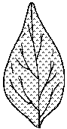  blade  The main part of the leaf is the blade | 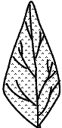  lanceolate  This blade is lance shaped, longer than broad and tapering to a point at the tip.
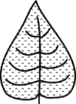  cordate  This is a heart-shaped blade. | 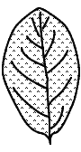  elliptic  The blade is shaped like an ellipse. It’s wider at the center and tapers off at both ends.
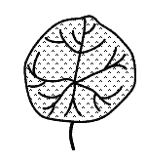  orbicular  The blade is round in shape. | 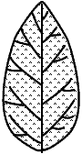  ovate  The ovate blade is oval, shaped like an egg.

