Name: __________________________________

Leaf Margins and Groupings
The shape of the edge or margin of a leaf is another way it can be identified. Three kinds of margins are Entire, Toothed, and Lobed.

 In this example the leaf’s edge is smooth. 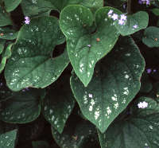

 The margin (edge) has shallow bumps. 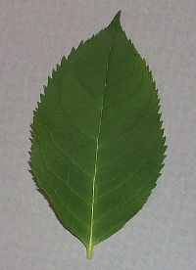
There are different examples of toothed margins. See them below.

The bumps point to the leaf’s tip. 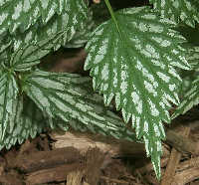

Here the edges teeth are broad and round. 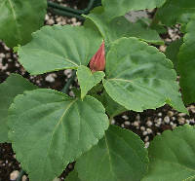

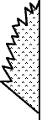 Incised Here the teeth are deeply cut, sharp and irregular.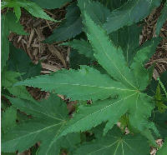

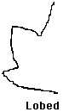 The leaf is made of finger-like parts. Count them. 