How Temp Affects Density
Name _________________________________ Date ___________________
Experiment 3 – How does temperature affect density?
View the demos and answer the following questions
- What is happening in the convection tubes? (Draw a picture.)
_____________________________________________________________________________

_____________________________________________________________________________

_____________________________________________________________________________

_____________________________________________________________________________

_____________________________________________________________________________

- Here is the setup for the next demo:
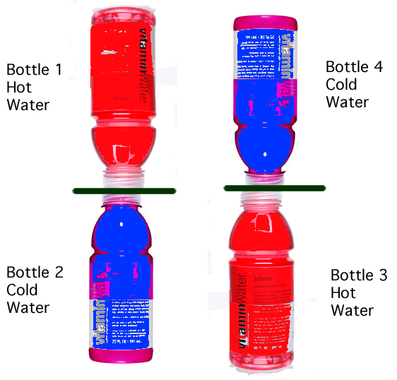

- On your own, predict what will happen when the cardboard squares that separate the liquid in the two plastic bottles are removed. Explain the reasons for your prediction.

- Now the teacher will remove the index cards that separate the liquids in the plastic bottles (both sets at the same time). Describe what happens in both sets of bottles.

  - Why do you think this happened?

Summarizing Questions
- Based on the last three experiments, what can you say about the relationship between density and temperature?

- Was there a heat energy transfer between bottles 1 and 2? How do you know?

- What type of heat energy transfer was it? (Conduction? Convection? Radiation?) Why did you choose the one you did?

- Was any heat energy transferred between bottles 3 and 4? How do you know?

- If you think there was a heat energy transfer, was it a heat conduction interaction, a heat convection interaction, or a radiation interaction? How do you know?

