Chimacum

Middle School
Mr. González’s 6th Grade Class Newsletter

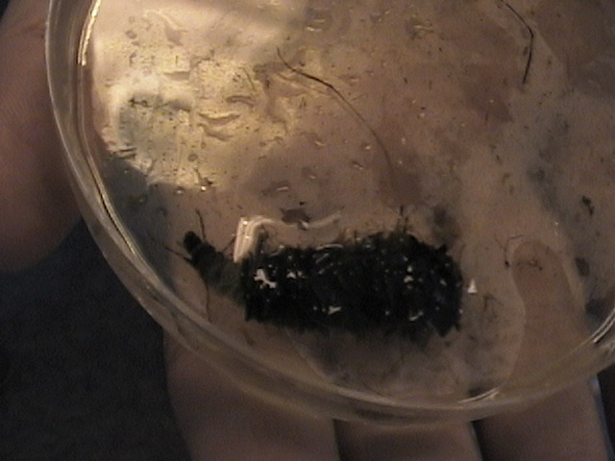
Fun Stuff!
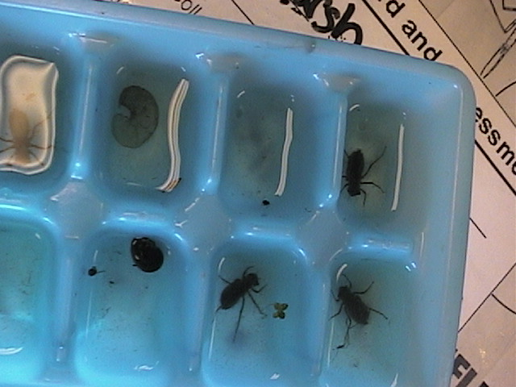
Tuesday, March 29, two Americorps volunteers visited us to teach my students about wetlands and macroinvertebrate identification. Pollution sensitive insects are indicators of the health of wetland ecosystems. It was a lot of fun and there’s more! The Hood Canal Watershed Project will pay for us to take a bus down the west side of the Hood Canal off Hwy 101 on Wednesday, April 13! Our students will share their results at the Hood Canal Youth Summit on June 2. Their data will be part of the multi-year study of the Hood Canal.
Volume 3, #2 - April 1, 2005

Study Canada?
We started our study of Canada with a funtastic Canadian Vacation project (http://educatoral.com/canadian_vacation.html)! On May 13 we will spend a wonderful day in British Columbia, Victoria, and on May 27 we will have our Canadian Trading Post (the trading post will be much like our Latin American Market Day).

Parent Volunteers
We need parent volunteers to help make our field trips successful. It will really help us if we can have a few parents come with us on April 13 to test the Hood Canal. We need about six parents to go with us to Victoria on May 13, and a bunch of parents to go with us to the Hood Canal Youth Summit on June 2. All parents are of course invited to the Canadian Trading Post on May 27 (if you can make it). If you can attend any of the above field trips, please send me a note with your child ASAP.

Chimacum Middle School

http://educatoral.com/menu.html
Important Dates:
Apr 13, 2005 – Water Quality testing down the west side of Hood Canal.
May 13, 2005 – Victoria Field Trip
May 27, 2005 – Canadian Trading Post
June 2, 2005 – Hood Canal Youth Summit
91 W. Valley Rd/PO Box 250
Chimacum, WA 98325
(360) 732-4219
Al_Gonzalez@csd49.org
Volume 3, #2 – page 2

Parent volunteers

Continued from p. 1
If you want to join us on the April 13 water quality testing field trip you can help kids use their probes and kits at every stop to quickly run their tests and record their data. We will stop for lunch and the Hood Canal Water Project is planning to have lunch for us! I will double check during Spring Break to make sure that is happening.

If you want to join us for the Victoria field trip there will be a cost associated because the school can’t afford to pay for the bus, the ferry, and the museum. I will let you know the costs as we near May 13. I will work with your child to assign you a small group of kids. Once you are in Victoria, you will be responsible for taking your group to all the activities and you might even have time to visit the shops near the ferry dock!

If you want to go with us to the Hood Canal Youth Summit on June 2, you will most likely be in charge of small groups also. You can make sure they get to the sessions they need to get to. I will learn about how the summit will work as we get closer to that date. The Hood Canal Watershed Project is also paying for the bus that will take us to Fort Flagler for this summit. We will be joined by a group of 8th graders who will perform their Pacific Northwest legends wearing masks they created. It should be a blast! So let me know as soon as you can which of these field trips you want to attend.
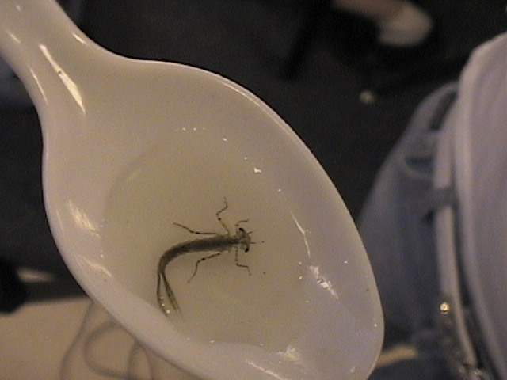

Chimacum

Middle School
Mr. González’s 6th Grade Class Newsletter

Responsibility
I’ve been working hard to keep my website updated and to keep my grade book current. This quarter I’ve given students three progress reports, one on the third week, one on the midterm or fifth week, and one on the seventh week. I advised students to use those progress reports to cross out missing work as they turn it in and to keep caught up while they make up missing work. I have allowed late work and I have allowed students to redo any and all assignments and/or tests. I invite students to come in at lunch and I find time to have students stay after school. I know you, the parents, are also working hard and I communicate with many of you regularly. At this time, I feel the need to hold the kids fully responsible for low grades.

The only things that I have right now to deny students are the field trips. I see not getting to go on the fun trips as a natural consequence of not doing their job. If I were their boss, I would not pick employees that do not work and cause trouble to go on exciting projects. I told kids that those who failed third quarter classes, I don’t know how many failed classes is too much yet, should not get to go on the April 13 field trip. This is especially true for those kids who promised me that they would make up most of their assignments if they got to go on the Ballard Locks field trip. I will spend as much time as it takes over Spring Break to go over all the late work that has been turned in to have final grades ready by Monday, April 11. At that time we will see how everyone did.

