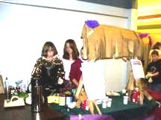

Chimacum Middle School

Chimacum

Middle School
Mr. González’s 6th Grade Class Newsletter

Volume 3, #1 - February 14, 2005
Happy Valentines Day!
Eagle Night!
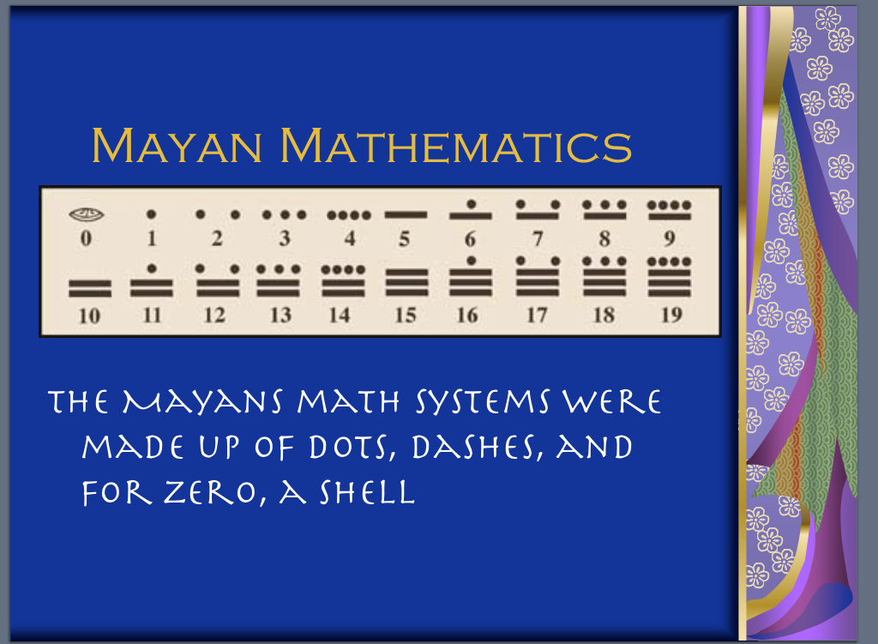
When: This Wednesday, Feb 16,
7pm to 8pm!
Where: Right here, Room 604!
What: Kids showing off work!
This is the third quarter and the second semester! Wow! We’re half way through our first year in middle school. Wednesday at Eagle Night some students will be presenting their social studies PowerPoint presentations. After every group practiced and presented, I chose the best ones to demonstrate our social studies project for parents.
Continued on page 2.
http://educatoral.com/menu.html
Important Dates:
Feb 16, 2005 – Eagle Night!
Mar 9, 2005 – NOSC Tree Planting
Mar 18, 2005 – Ballard Locks
Mar 29, 2005 – Macro Class!
June 2, 2005 – Hood Canal Youth Summit
Reading Logs
This will be the third week that I have been sending home reading logs. Students are to record how much they are reading. They should be reading at least 15 to 20 minutes a night and then summarize what they read in their logs (log is on my web).
Continued on page 2.
Field Trips and Events
We’ve got other great things coming up. I’ve scheduled a tree planting to help the North Olympic Salmon Coalition, a Macroinvertebrate (bug) class taught by Americorps volunteers, and we’ve been invited to a great water quality summit to share the great things we are doing in science! (See attached handouts for info.)
Continued on page 2.
91 W. Valley Rd/PO Box 250
Chimacum, WA 98325
(360) 732-4219
Al_Gonzalez@csd49.org

Chimacum

Middle School
Mr. González’s 6th Grade Class Newsletter

Volume 3, #1 – page 2

Eagle Night

Continued from p. 1
All students will have the opportunity to show parents all the things they have been doing in 6th grade so far. Come see all the wonderful things your child is doing such as the great Cispus websites, the wonderful Tsunami websites, the Maya, Aztec or Inca PowerPoints, and the water quality websites that are in progress! We hope to see you there!

Reading Logs
Continued from p. 1
By each Thursday, kids should get a parent signature and turn their logs in by Friday. I have only received a few each week so many kids (literally 19 to 21 each week) aren’t getting this done and their language arts grade will be affected. Not taking care of responsibilities, like homework, will not help students be successful in secondary school. Those who do well in class, in their groups, on projects, and who do and turn in homework will be the ones who get to participate in all of our upcoming events.

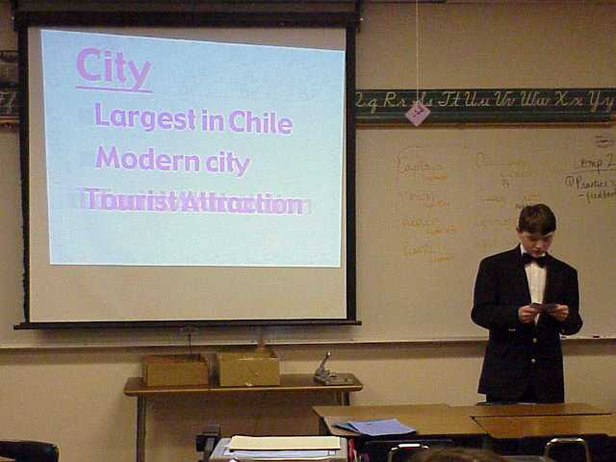

Field Trips and Events
Continued from p. 1
Please contact me if you’re wondering about your child’s behavior because I will take only those students who cooperate in class regularly. I’ll be contacting parents prior to any field trip or event by sending home a letter if your child cannot participate. Getting yellow plans in class, being sent out when not cooperative, excessive talking and not doing work or homework after several warnings and reminders is hurting the grades of several students and ruining the experience of others. I would like to reward those students who continually strive to do well in class and accept responsibility. Unfortunately, to do that requires that those who choose not to do well on a regular basis must miss out. Stay tuned.

