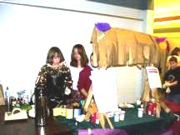

When you call a teacher at school, the secretary will take your message and leave it in our box. I will try to get back to you that day or at least by the next day. If you can’t email me and want to get a message to me quicker, send a note with your child or write me a note in your child’s planner and have your child give that to me. Otherwise, please feel free to come and see me in school. The best times to talk to me are 7 to 7:25am, 11:40 to 12:20pm or after school (I usually stay until after 4pm).

91 W. Valley Rd/PO Box 250
Chimacum, WA 98325
(360) 732-4219
EducatorAl.com
If you can at all, please try and visit my class website. I try to update it either every evening or at least during the weekend. The old website address doesn’t work very well for everyone so please use this one: http://educatoral.com/

Chimacum Middle School
Hello room 604 parents!
I got to meet some of you at our orientation and I’ve met some of you before or during the first week of school. I just wanted to touch bases and let you know how to contact me. Emailing me is the quickest and easiest way. My email address is Al_Gonzalez@csd49.org or you can call me at school at 360-732-4219.

Chimacum

Middle School
Mr. González’s 6th grade class newsletter

