Chimacum

Middle School
Mr. González’s 6th Grade Class Newsletter

Volume 1, #2 - Nov 28, 2005

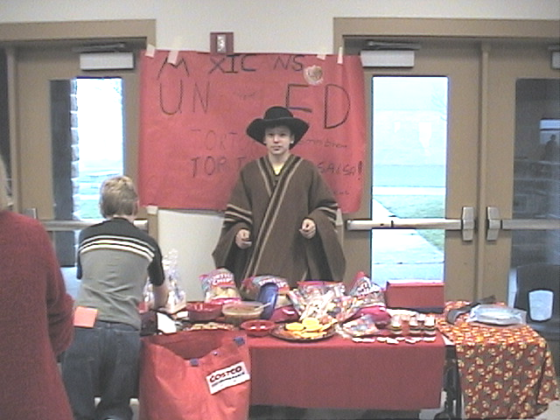

End of 1st Trimester!
December 1 is the last day of the first trimester! I gave students an updated copy of their progress report on Tuesday, Nov 15, and I am giving them another updated copy today! This is the last chance to make anything up or do extra credit because I have to have my grades all done this weekend.

Some of our projects will carry over to the second trimester such as the Latin American study for Market Day and the Aztec, Maya, and Inca WebQuest. In science we will start to work on our Energy, Machines, and Motion kit as well as work on a Yo-yo unit as part of our physical science study.

December 2 is our trimester break so there will be no school on that day. December 8 both Ms. Langston’s class and my class will be going on a field trip to plant trees for the North Olympic Salmon Coalition! Contact me if you would like to join us. Permission slips will be coming for that soon.

Market Day
We are working on our Latin American project and it will culminate with our Market Day celebration. Please visit the website for more information:
http://educatoral.com/latin_am_project.html

Parents are invited to join our open-air market on Thursday, December 15, from 8:30am until about 10:00am. Just find your child’s homeroom teacher, or any of the 6th grade teachers, and we will give you class money to spend on the wonderful booths!

Please read the Market Day form attached to this newsletter. Items for sale at the Market Day event are made at home. Parents can help but kids need to be involved (they can’t have you do all the work). We also do not want anyone thinking that you have to spend a lot of your own real money on this. Kids can still get an A if you spend very little money.

Chimacum Middle School

http://educatoral.com/menu.html
Important Dates:
Dec 1, 2005 – Last day of trimester
Dec 2, 2005 – Trimester Break
Dec 8, 2005 – Tree Planting
Dec 15, 2005 – Market Day
Dec 19 to Jan 2 – Winter Break!
91 W. Valley Rd/PO Box 250
Chimacum, WA 98325
(360) 732-4219
Al_Gonzalez@csd49.org

