Chimacum

Middle School
Mr. González’s 6th Grade Class Newsletter

Volume 1, #5 - April 21, 2006

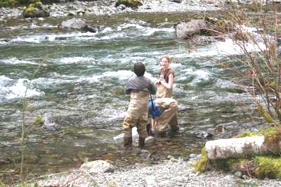

Science Update!

Students have done a great job testing Chimacum Creek and five sites along the east and west sides of the Hood Canal! Through my grants and grant monies from a North Mason High School teacher all expenses have been paid for our students to do real science and provide a service for our creek and the canal! Please visit our website for more information.
http://educatoral.com/chimacum_creek/cms_water_quality.html

Now students will begin to learn what their specific tests mean. Each team specialized in one or two different water quality measures. Once they learn what their results mean, each team will share what they learned with the class so we can all understand the big picture. Then students will create websites to share their findings and any recommendations. A big thanks to Audrey from NOSC for including us in their work with the Chimacum Creek.

Continued on page 2.
Macro Sampling

Social Studies Update!

We are done with our Aztec, Maya, and Inca WebQuest PowerPoint Presentations! (http://educatoral.com/aztec_maya_inca_webq/webquestindex.html) Students presented very well as they shared what they learned about the civilizations they studied.

Now students are busy learning about Canada. In order to prepare students for the Victoria field trip on May 12 and their Canadian Trading Post on May 25, they are busy working on a Canadian Vacation project. This is a three phase project that will teach students about Canada’s 10 provinces and 3 territories. Visit the website for more information: http://educatoral.com/canadian_vacation.html

Continued on page 2.

http://educatoral.com/menu.html
Important Dates:
May 4, 2006 – Midterm (Progress Reps)
May 5, 2006 – Victoria perm & $$ due
May 12, 2006 – Victoria Field Trip!
May 25, 2006 – Canadian Trading Post
May 31, 2006 – Hood Canal Youth Summit Field Trip!
Chimacum Middle School
91 W. Valley Rd/PO Box 250
Chimacum, WA 98325
(360) 732-4219
Al_Gonzalez@csd49.org

Chimacum

Middle School
Mr. González’s 6th Grade Class Newsletter

Science Update!

Continued from p. 1
Audrey worked with four groups from the 6th grade in October to collect samples of our creek’s macroinvertebrates, then she took our kids tree planting to help restore sections of the creek to their natural state, then she returned this Spring to share with us the results from the macro sampling and to teach us what that may mean!

The Hood Canal findings will be shared with other schools who tested sites along the Hood Canal this year. Our students will share what they learned at the Hood Canal Youth Summit, May 31, at the Twanoh State park. North Mason High school will also pay for our bus trip there!

Students still need to work on their Energy, Machines, and Motion Wiki. So if you don’t have an internet connection at home remind your child that he or she can use our class computers at lunch or after school.
http://www.seedwiki.com/wiki/energy_machines_and_motion/

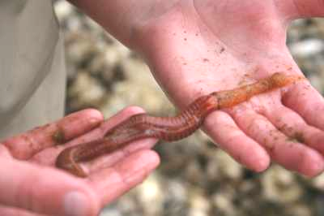
Marine Macroinvertebrate!

Social Studies Update!
Continued from p. 1
Students need to finish and edit their Latin American country information for our Latin American Wiki
http://www.seedwiki.com/wiki/latin_american_facts/

Class Blog!
Our class blog is looking great now as more and more kids write. This trimester, blogging is again part of students’ grades so everyone needs to keep blogging and responding to each other’s blog entries (http://mrgonzalez.org/)! Our classroom blog is a safe and secure way for our students to publish their questions and comments on the topics we are studying this year in class. This trimester I expect to see more writing and more involved responding so it is getting harder to get the top grades.

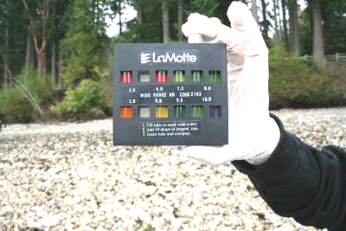
pH results!
Volume 1, #5 – page 2

