Chimacum

Middle School
Mr. González’s 6th Grade Class Newsletter

Volume 1, #3 - Jan 3, 2006

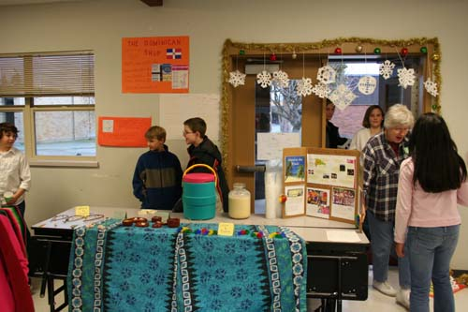

Science Update!

Now that we are done learning about Physical Science and the Scientific Method through the Duncan Yo-yo unit I purchased, we are going to continue learning Physical Science through Energy, Machines, and Motion (EMM), a Science and Technology Concepts for Middle School (STC/MS) kit that our school purchased.

The STC/MS kit is from Carolina Biological (http://www.carolina.com/stcms/modules/EMM.asp) and it is fantastic. We will continue to work through the lessons and labs from that EMM kit until about March when we will shift to our Chimacum Creek Water Quality project (http://educatoral.com/chimacum_creek/cms_water_quality.html). We began to work on Chimacum Creek and are expanding our project to work with Hood Canal schools to help them monitor the Hood Canal. Check my website for more information on our study of Physical Science and our Water Quality Project and the above links by visiting my homework section.
(http://educatoral.com/hw.html)
More information continued on page 2!

Social Studies Update!

We need to finish our Latin America Project
(http://educatoral.com/latin_am_project.html). Students need to complete Phases 2 and 3 (Phase 4, Market Day, was a huge success – thank you parents for helping your children do a great job). Students still need to wrap up their class projects and reports and then they will share those with their classmates.

Once we are done with the Latin American Project, we will finish our Aztec, Maya, and Inca WebQuest (http://educatoral.com/aztec_maya_inca_webq/webquestindex.html) as students complete and present their PowerPoints.

We will also work on our Latin American Facts Wikipedia, which will be an online resource of all the wonderful things students are learning.
Continued on page 2.

Chimacum Middle School
http://educatoral.com/menu.html
Important Dates:
Jan 14, 2006 – Science Olympiad
Jan 16, 2006 – No School, MLK, Jr.
Jan 18, 2006 – Early Release
Jan 18, 2006 – Eagle Night, 6:30pm
91 W. Valley Rd/PO Box 250
Chimacum, WA 98325
(360) 732-4219
Al_Gonzalez@csd49.org

Chimacum

Middle School
Mr. González’s 6th Grade Class Newsletter

Science Update!

Continued from p. 1
I have also started a class Energy, Machines, and Motion Wiki webpage. A Wiki is a website that our students add definitions for their science vocabulary. As students add definitions, other students can alter the definitions, fix them, add to them, or add their own definitions. This will be our Wikipedia, which is an online encyclopedia created and added to by regular people. Maybe our Wikipedia will be a resource to other students on the web studying energy, machines, and motion. Here is the link to our Wiki (you can also access this link from my class website):
http://www.seedwiki.com/wiki/energy_machines_and_motion/

Science Olympiad Competition
If your child is really interested in science, come watch the Science Olympiad competition on Saturday, January 14, which our school is hosting. When our 6th graders enter 7th grade, they will be eligible to participate in the competition.

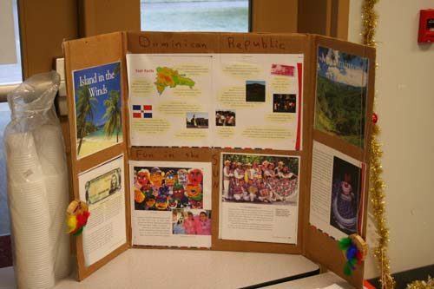

Social Studies Update!
Continued from p. 1
I will introduce our Wiki’s to students soon so stay tuned, check the class website, and ask your child what that is all about. It’s a fun, new, and exciting way to share what we are learning. Here is the link to our Latin American Facts Wiki (you can also access this link from my class website):
http://www.seedwiki.com/wiki/latin_american_facts/

Class Blog!
I am also waiting to get permission from parents to have students start blogging on our Class Blog (http://mrgonzalez.org/)! Our classroom blog is a safe and secure way for our students to publish their questions and comments on the topics we are studying this year in class. See my class website to download the blog information and permission letter if you did not receive one.

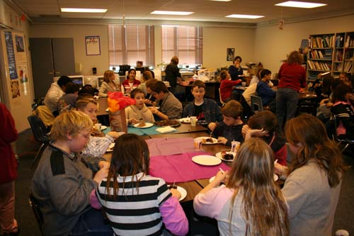
Volume 1, #3 – page 2

