Mouth of Chimacum Creek
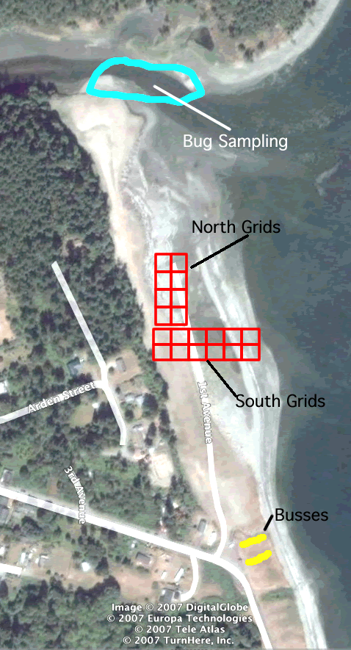
Field Trip Instructions:

3rd period teams 1 – 8
4th period teams 1 – 10
5th period teams 1 – 10

8:40 to 8:55am – Load Busses
Bus #1 – 3rd period Sci and Teams 1-5 of 4th period Sci
Bus #2 – 5th period Sci and Teams 6-10 of 4th period Sci

9am to 9:30am –
Photograph plants: 3rd period
North grids: 4th period
South grids: 5th period
Benthic groups: 3rd period two tree groups

9:35 to 10:05am –
Photograph plants: 5th period
North grids: 3rd period
South grids: 4th period
Benthic groups: 5th period groups 2 & 5

10:10 to 10:40am –
Photograph plants: 4th period
North grids: 5th period
South grids: 3rd period
Benthic groups: 4th period groups 3 & 5

10:45am – Head back to school!

