Chimacum Middle School

Latin Exploration

Mr. Gonzalez

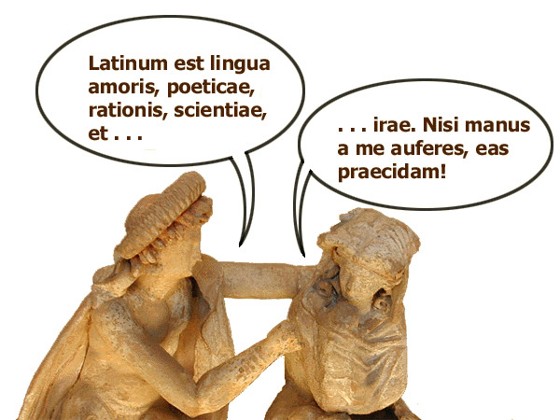
What are they saying? This course will help you find out.

Description:
This will be a beginning Latin course. We will practice speaking Latin as well as using Latin words to find the root words that make up much of the English and Spanish vocabulary.

Learning outcomes:
Students will practice conversational Latin. Pronunciations will be based on how linguists believe Latin was spoken circa 1st Century BC to 1st Century AD. The V sounds like a W, the C sounds like a K, H will sound like our H, the G will be a hard G only, and the J sounds like a Y.

Students will keep a vocabulary list, sometimes in handout format, showing the Latin words and English and Spanish words derived from the Latin words.

Materials needed:
Students will need a notebook for Latin class and they will need to bring that notebook to Latin class everyday.
Student participation will be a huge part of their grade since they will need to be in class to practice speaking Latin.

