Chimacum Middle School
Social Studies Unit

Altar History/Info

A typical altar begins with a table on which are placed boxes to represent the tombs and all is covered with a white tablecloth or sheet or with papel picado, paper cutouts with special themes related to the season. Long stalks of sugarcane or carrizo are tied to the front legs of the table, formed into a triumphal arch above the altar and decorated with flowers. The images of the saints and the family dead are placed on the altar and everywhere there are flowers: The golden flower of death, the Zempoalxochitl, the vibrant red cresta de gallo, perhaps some rich purple agapantos and the pure white nube.

The special offerings of food may include mole, nicuatole, pumpkin cooked with brown sugar, cane sugar and tejocotes. Beautifully decorated pan de muerto, chocolate, pecans and peanuts. Cooked chayote and fresh fruits - oranges, lemons, bananas, jícama, tejocotes, nísperos and pineapple. If the deceased smoked or drank, then cigarettes and mezcal are placed on the altar together with any other special foods or tributes which were a favorite in life. If the altar is for an "angelito" or dead child, it will also include favorite toys and many white flowers. Then comes the lamp with oil of higuerilla, the wax candles, white or yellow adorned with black crepe paper. An especially elaborate altar may also feature a colored sand and seed painting on the floor in front of it representing a particularly esteemed saint.

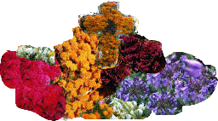

The concept of the Danse Macabre brought from Europe was adopted by the Mexicans and fused with the prehispanic customs and attitudes, resulting in a uniquely Mexican custom especially prevalent in Oaxaca - calaveras and catrinas and the omnipresence of skeletons, skulls and sepulchres. Candy skulls, wood and clay figures depicting skeletons dressed as doctors, judges, teachers, footballers, tennis players, prostitutes - every conceivable profession and pastimeis burlesqued. Serious paintings and sculptures in the famous Oaxacan black clay and other materials appear in stores and museums, as well as on family altars.
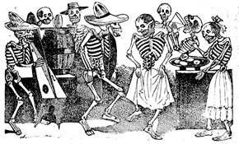

The Calaveras are widespread drawings and verses satirizing "dead" politicians, teachers, and friends and there is a special section of calaveras in the newspapers "honoring" those in the public eye.

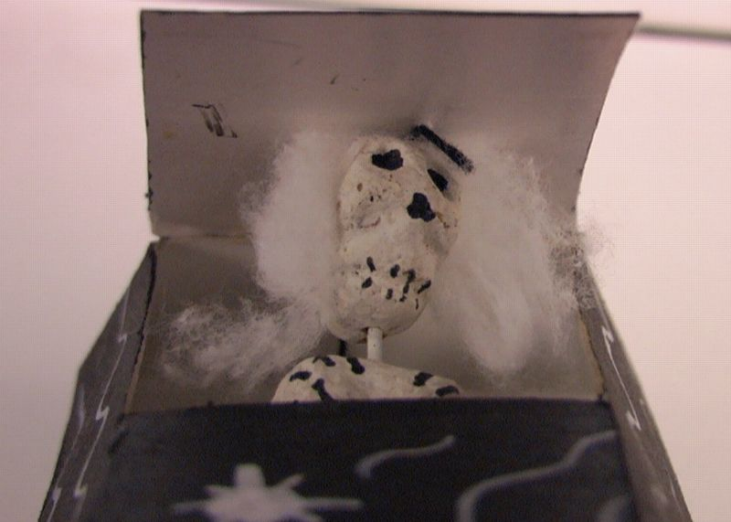

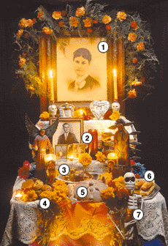
In the Mexican tradition altars such as the following were put together to honor the dearly departed. Offerings or ofrendas of food, drink and mementos were placed on the altar for the return of the departed on Nov 1st and 2nd. The altar was the center of the Days of the Dead observance. The decorations depend on the regional traditions and will look different depending on where you are.

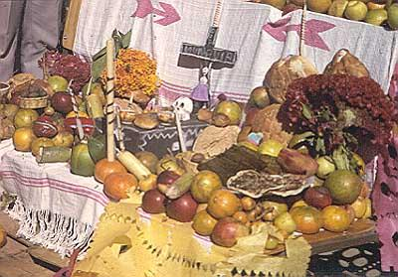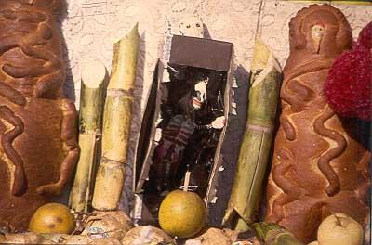

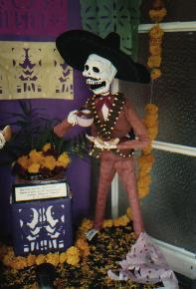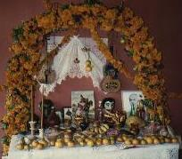

Papel Picado

Making things out of colored tissue paper has long been a Mexican folk tradition. One of the common names for the material, papél de China, or Chinese paper, gives us a clue as to its origin. Paperwork was apparently among the imports that poured in from the Orient on the annual Pacific treasure fleet that plied its way between the Far East and Acapulco, laden with such exotic goods as silver, ivory, spices, and porcelain. Once the craft arrived in Mexico it became the basis for many important and widespread folk art forms.

There are examples of papel picado dating back to the early 20th century. Cut from colored tissue paper to simulate lace, papel picado can be seen hanging from Day of the Dead altars and around graves during November. Also during Christmas and other celebrations the papel picado decorates indoor and outdoor festivities in Mexico.

Papel picado is a form of "folk art," meaning that it is a popular traditional art form handed down from generation to generation. In Mexico template patterns cut the designs into stacks of colored tissue paper producing many paper cuts-outs at once from a single pattern.

Materials: 8" x 10" sheets of colored tissue paper, stacked and folded in half like a book
Scissors
Straight pins
String
Glue
Pattern

Directions: Pin the pattern to the paper taking care to place the center edge of the pattern on the folded edge of the tissues.
Cut into the pattern and tissue first around the edtes to make the border. Then cut out the large "negative"shapes by first puncturing the center of the areas to be cut out and then following the outlines. The small geometric shapes can be cut out by first folding on the dotted lines and then cutting the solid outlines.

When completely cut, unfold and separate the tissues. Fold each tissue along the top edge about 1/2". Apply glue to this flap and wrap each tissue around the string, pressing the glue into the string to secure.

Patterns: 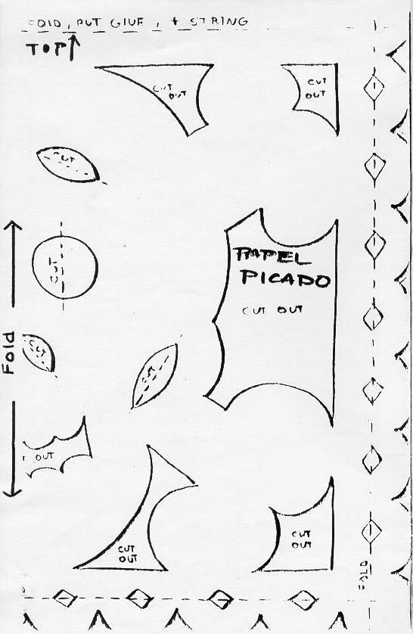

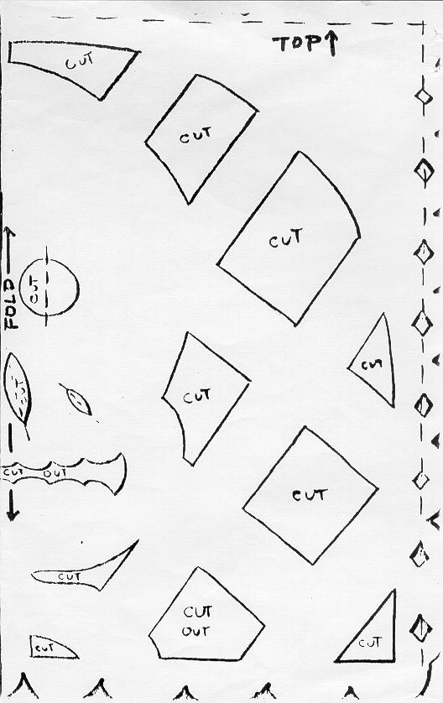

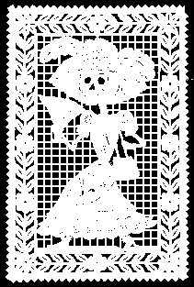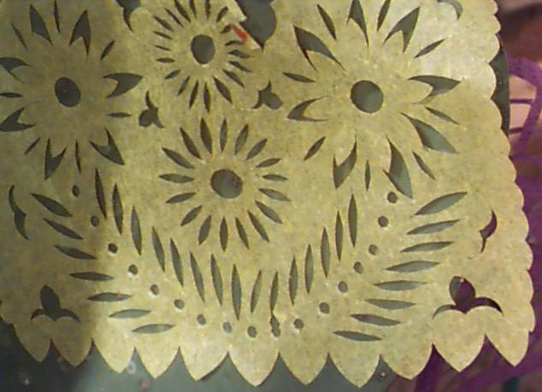

Flor de muerto or Flower of the Dead
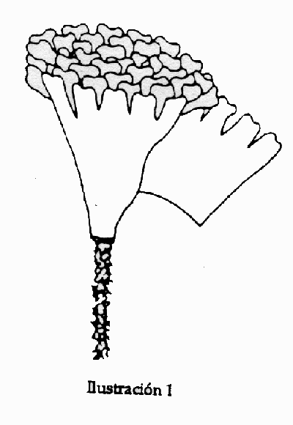
By taking tissue paper and cutting it in the pattern shown above and wrapping it around a pipe cleaner, you can make flowers for the dead decorations.

Ingredients:

For skulls:
* 1 TB powdered egg white
* 3/4 cup water
* 1-1/2 tsp vanilla extract
* 1/4 cup light corn syrup
* 8 cups powdered sugar
* 2 cups cornstarch

For Icing:
* 1/2 tsp powdered egg white
* 3 TB water
* 1-1/2 cups powdered sugar
* 3 drops red food coloring
* 2 drops cinnamon extract
* 3 drops blue food coloring
* 2 drops peppermint extract
* metal sequins for decorating eyes

Directions:

Whisk powdered egg white and water together until foamy. Add vanilla extract and corn syrup. Whisk until blended. Add powdered sugar. With a spoon, and then by hand, mix until a firm paste forms.

Dust a jelly roll pan with 1 cup of the cornstarch. Knead sugar paste in cornstarch for a few minutes until it becomes smooth and pliable. Roll the dough into a ball. Wrap it in plastic and refrigerate it until chilled.

Begin by forming dough into round balls, each about the size of a small fist. Use more cornstarch to prevent sticking, if needed.

Use your hands to sculpt the ball into a skull shape. Sculpt eye and nose hollows with your thumbs or a blunt knife.

To prepare the icing, whisk powdered egg white and water together until foamy. Add powdered sugar and beat until smooth. Divide mixture into two small bowls. Add red food coloring and cinnamon extract to one and blue food coloring and peppermint extract to the other. Mix to blend the colors in each bowl.

Fill two pastry bags with icing mixtures. Decorate skulls with icing. Allow objects to dry. Weather conditions affect drying times. Skulls may take anywhere from several hours to 48 hours to fully dry.

