Name _____________________________________________ Date __________________________
Bacteria in Our School
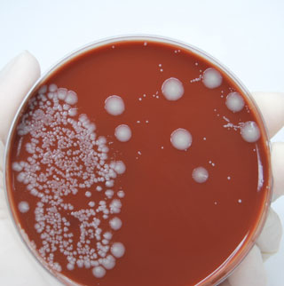

Background information:
Bacteria are a large group of unicellular, prokaryote, microorganisms that are so small, 100 average sized bacteria could ﬁt across the period at the end of this sentence. Bacteria have three basic shapes: spheres (cocci), rods (bacilli), and spirals (spirilla). They are found in every habitat on Earth and are in the air around us all of the time. Forty million bacteria cells can be found in a gram (a nickel weighs 5 grams) of soil and one million in a milliliter (one-ﬁfth of a teaspoon is a milliliter) of fresh water; large numbers of bacteria are found on the skin and in the digestive system. Most bacteria are harmless, but some species are disease producing.

Agar is a gel-like substance that is derived from seaweed. Bacteria use it as a food supply. Depending on the type of bacteria, circle-shaped colonies of various colors will appear a few days after being introduced to the agar medium. Bacteria can reproduce every 20 minutes in optimum conditions, so a colony that starts with one bacterium can quickly grow into a colony that can be observed on the surface of the agar.

- You will be checking four parts of the school for bacteria. Each team will get one prepared petri dish (it will have a nutrient agar). What question do you want to answer? _________________________________________________________________________________________
___________________________________________________________________________________________________
___________________________________________________________________________________________________
- What four parts of the school will your team check (your mouth can be one of the four):
  - _________________________________________________________________
  - _________________________________________________________________
  - _________________________________________________________________
  - _________________________________________________________________

- Where do you predict you will find the most bacteria (or where will you find none or fewer bacteria)? _________________________________________________________________________________ _____________________________________________________________________________________________________
_____________________________________________________________________________________________________
- We will be taking some precautions to keep you and your teammates safe.
  - The petri dish will be upside down to keep condensation from getting on the agar or the growing bacteria. When you first handle the petri dish be careful not to lose the lid or you may introduce airborne bacteria into the agar thereby contaminating your sample.
  - Do not touch anything with your fingers or you will contaminate your sample.
  - Wear goggles and use gloves when handling the petri dish after it has been incubated, especially if bacterial colonies grew!
  - Do NOT open the petri dish. View and describe the bacteria through the top of the dish.
- This is how you should label your team’s petri dish on the bottom and sides only (not on the top or you won’t be able to see anything):
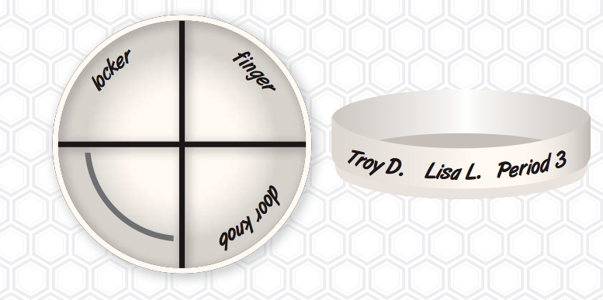

- You will use Q-tips, make sure your Q-tips are moist. Putting them under running water in the sink should keep them from getting contaminated. Use baggies or something to keep your Q-tips from getting contaminated once you swab your chosen areas.
- You should swipe your Q-tip in the agar nutrient in a zigzag manner like this:
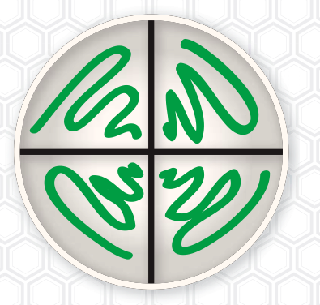

- Write a step-by-step procedure. Once your procedure is approved, your team can begin your experiment. Make sure your last steps include disposing of your gloves and petri dish (making sure you don’t come into contact with the bacteria that are inside).

Data Table
Sources | Day 1 | Day 2 | Day 3
Record your results and observations. You will make observations of your experimental Petri dish for a couple of days. These will be recorded in the data table above. Be speciﬁc in your observations using descriptive words like tan color, shiny, irregular edges, and 8 mm colony, etc.

Conclusion:
Analyze your results from your observations and write a paragraph that reports what you found. Make sure you include the following: Restate your problem question, describe your ﬁndings including some data examples, and tell if your hypothesis was supported (found to be correct) or not supported (found to not be correct). Additionally, include an error analysis (possible places where errors may have occurred that affected the data) and suggestions for further experimentation.

