GreenSTEM Environmental Youth Summit
May 17, 2011

Dear Parent(s) or Guardian(s),

We are excited to be participating in this year’s GreenSTEM Summit on May 17th at the Hood Canal Salmon Enhancement Groups/Pacific Northwest Salmon Center in Belfair, WA at 600 Roessel Road, Belfair. This event brings students from schools where environmental studies are taking place like our Chimacum Creek water quality project. Students will get to participate in learning about environmental issues as well as meet with other students to share the work they’ve done at their school with regards to environmental education. Chimacum 6th graders will get to share what they learned about water pollution, salmon, water quality and Chimacum Creek. They will show how they collected data and explain what their data means.

Here is a schedule of what our day might look like. If you are interested in joining us as a chaperone please let Mr. González know. Then join us on the 17th and you can ride on your child’s bus!

Overview of the May 17th (tentative- some times may change)
8:00 Leave Chimacum Middle School – 2 Busses
Bus 1 – Mr. Olafson’s class and Teams G1 – G5 from Ms. Langston’s class
Bus 2 – Mr. Meacham’s class and Teams G6 – G10 from Ms. Langston’s class
9:00 Students arrive from around the Canal
9:15 – 10:15 Exploring stations provided by EcoNET Partners and PNWSC/HCSEG Farm at Water’s Edge
10:15 – 11:45 Welcome Gathering and Sharing Circles
Students will gather in small groups with students from other schools and share their restoration and monitoring activities. Student groups will also develop their vision and intentions for the future of Hood Canal (or our creek).
11:45-12:30 No Waste Lunch
12:30-12:45 Orientation for afternoon of NatureMapping activity
12:45 – 1pm NatureMapping explorations (we will not be able to do much of this because we need to leave by 1pm!
1:00pm Depart
2:10pm Arrive at Chimacum Middle School – Go to 6th period class.

Every student needs to bring a sack lunch on this day. The next page of this packet explains how your family can pack a waste-free lunch if you can. Please sign the field trip permission slip and the photo release form and have your child bring it to Science as quickly as you can so that we can get this trip planned and ready to go.

------------------------------------------------

If you are interested in joining us as a parent chaperone please cut this off and return to Mr. González with the field trip permission form and photo release.

____________________________________________________ ____________________________________________
Parent Name Student Name

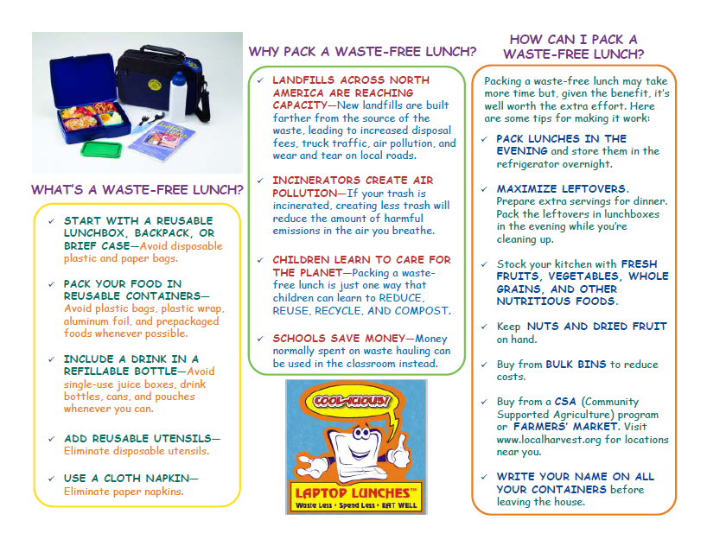
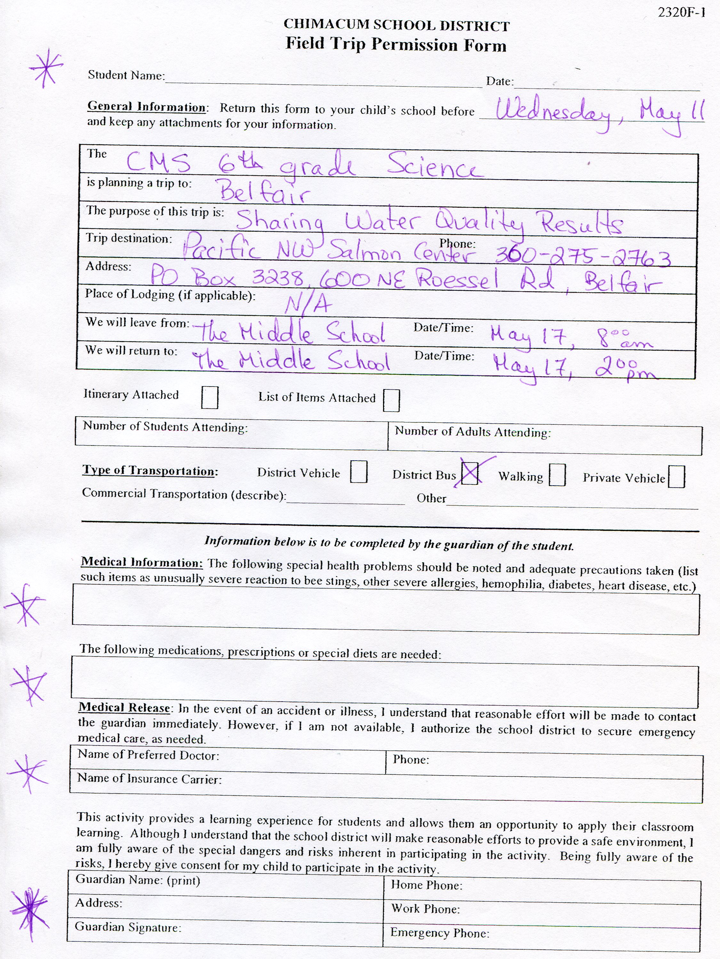
Photo, Footage, and Student Work Release Form

I hereby grant permission for the Pacific Education Institute, the Washington Forest Protection Association, the Puget Sound Partnership, The Russell Family Foundation, Hood Canal Salmon Enhancement Group, Olympic Educational Service District, and their affiliates to use any pictures, video footage or student work involving or related to my child,

(child’s name)______________________, in any newspapers, websites, magazines, television spots or other forms of media. These materials (pictures/footage/student work) are being taken/collected and shared with my knowledge and permission.

Parent or Guardian Name _______________________________
Signature____________________________________
Phone #__________________________
Date _____________________

