April 12, 2004
Web Design from Beginning to End
A new quarter begins and Web Design for 8th graders meets daily in room 604 from 11:44 to 12:35pm.
In this class, eighth graders will learn all aspects of web design from storyboarding their ideas, to optimizing graphics, to uploading their completed works to our web server. This class is project-based and students will be working in cooperative teams. Part of students' grades in this class will come from being on-task without disrupting the class. It is very difficult to fail this exploratory but if students do not work on their projects with their team (some students prefer to socialize instead of work), they can receive a D or an F in Web Design. This really should be a fun course where students learn valuable skills that are needed in today's high-tech world. The skills that students learn in this class will also help them create their very own electronic portfolio when they enter high school next year. Students will use Macromedia’s Studio MX to create their graphics and webpages.
Although it is not necessary for this course, teams may decide to create an About Us page for their website. On an About Us page, students have the option of using a picture of themselves. If you do NOT want your child to have her or his picture on the Internet, please send me a note stating that and tell your daughter or son not to do so. Remember that they do NOT have to use any pictures of themselves to complete any project in this class. What they have to publish are their works, which includes anything they write or create themselves such as artwork.
Mr. González
Al_Gonzalez@csd49.org
http://eagle.csd49.org/comp2/
Real Life Skills
Although few us will end up with a career in web design or graphic arts, this class will benefit all students. Most careers depend in some way or another on technology. By using technology and working with different software, we improve. All software have similarities and the more programs our kids become familiar with, the better prepared they will be for their futures. Whether or not students get to use a PC with the Windows operating system in schools really does not matter. We at Chimacum Middle School use programs such as Microsoft Office and Macromedia Studio MX, which are used by professionals both in the PC world and in the Mac world. Exposure is our best bet to prepare our students. This course will provide just that.
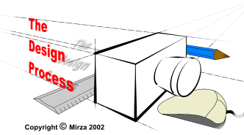
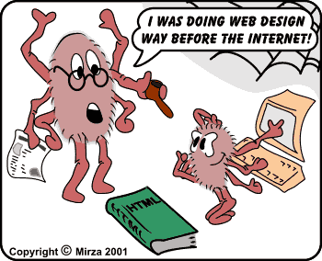

Inside This Issue
1 | Web Design from beginning to end
1 | Real Life Skills

