Tree Stump
Directions: Use the following information to answer questions 1 through 5.
Brian had to move a loose stump from a hole in his backyard. The stump was too heavy to lift. While solving this problem, Brian recorded the stages of his design process as follows.
Problem: Lift a heavy stump out of a hole.
Gather Information: A 1-Newton force could lift a 4-Newton weight when a meter stick is used as a lever, as shown in the Lever System diagram.
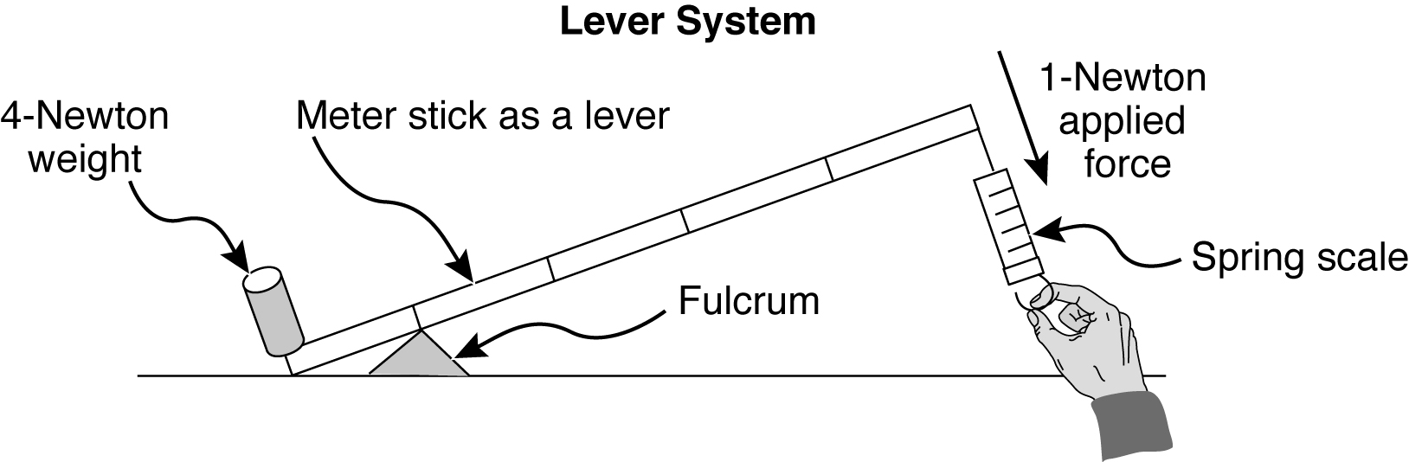

Explore Ideas:
- Use a long lever to lift the heavy stump.
- Pull the stump up a ramp.
- Lift the stump with a pulley.
- Get more people and all lift the stump at once.
Plan Summary: Use a long shovel as a long lever and a rock as a fulcrum because the rock is strong enough to hold up the shovel and tree stump.

Tree Stump
Steps to do the Plan:
- Move the rock close to the stump.
- Put the shovel blade under the stump and rest the handle on top of the rock, as shown in the Diagram of Solution.
- Push down on the end of the shovel handle while keeping the shovel blade under the stump and the shovel handle on top of the rock.
Diagram of Solution:
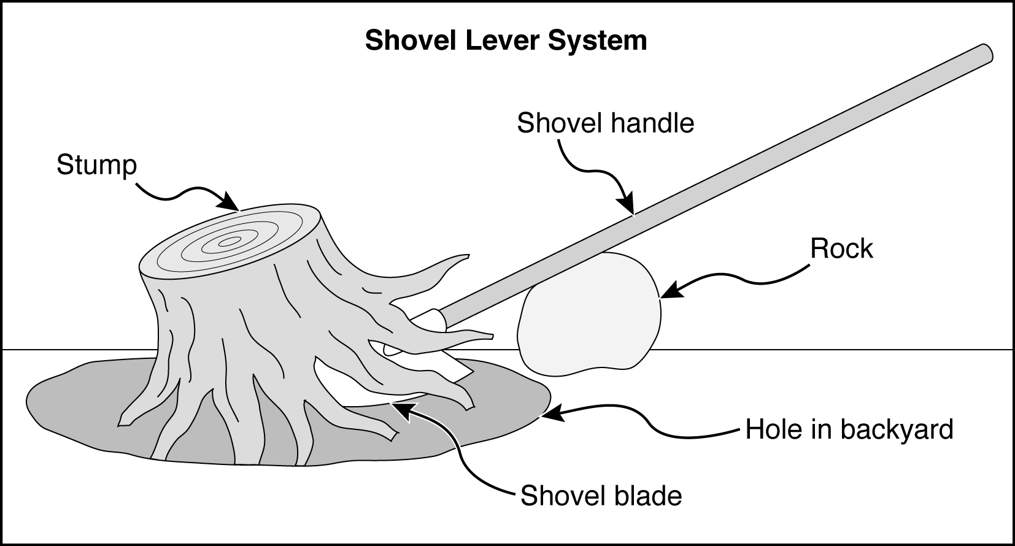

Test Solution: Apply a force to the Shovel Lever System by pushing down on the end of the shovel handle. Measure the height of the lifted stump.
Test Results: The stump was lifted 4 centimeters above the ground.

Tree Stump
1 Which of these lever systems is similar to the Shovel Lever System?

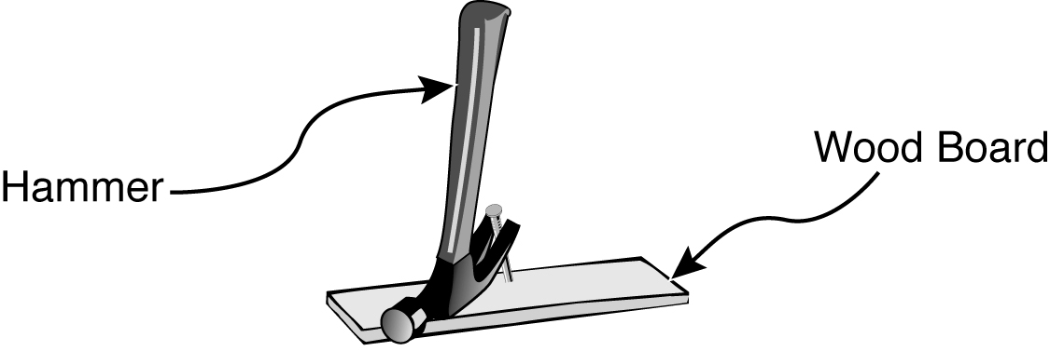

- A.

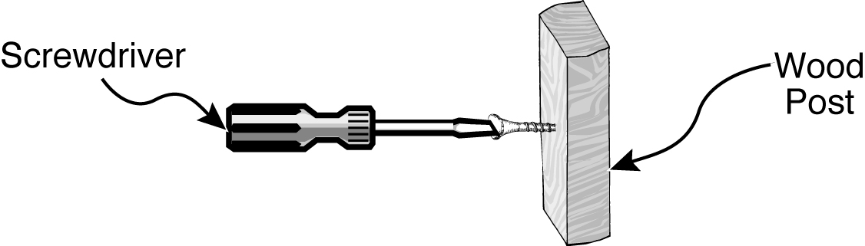
- B.

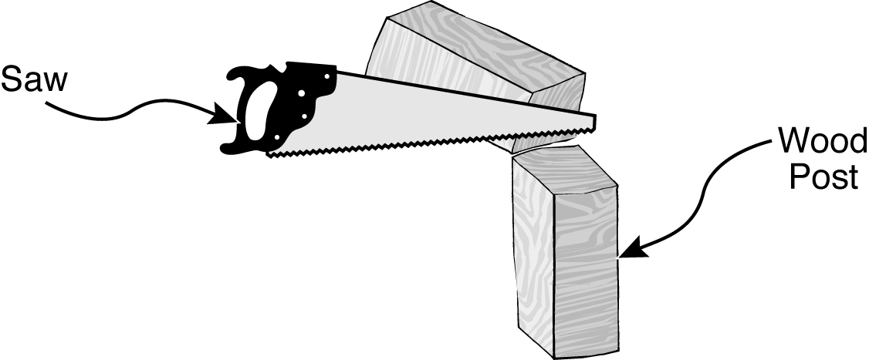
- C.

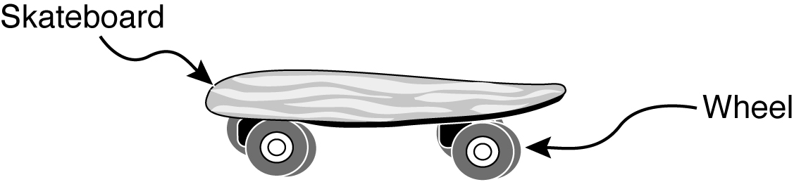
- D.

Tree Stump
2 In which diagram below does the stump have the greatest potential energy?

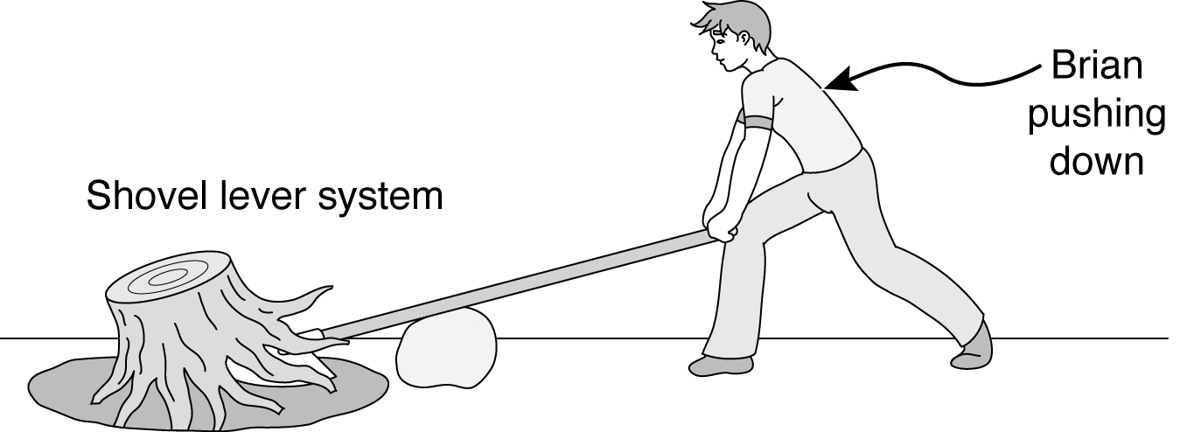

- A.

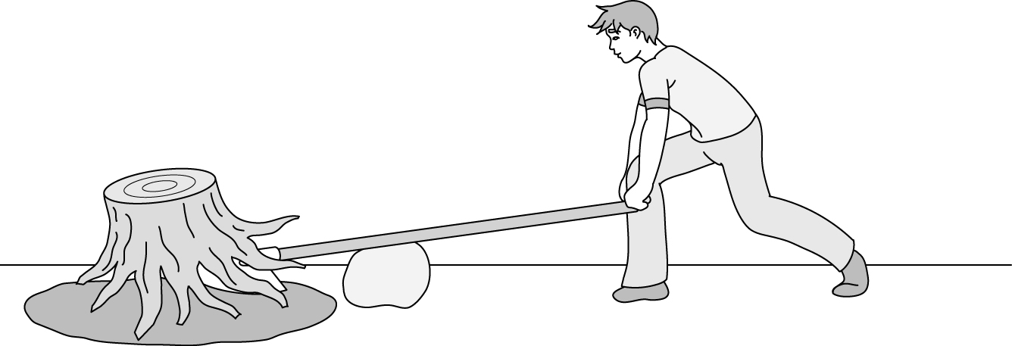

- B.

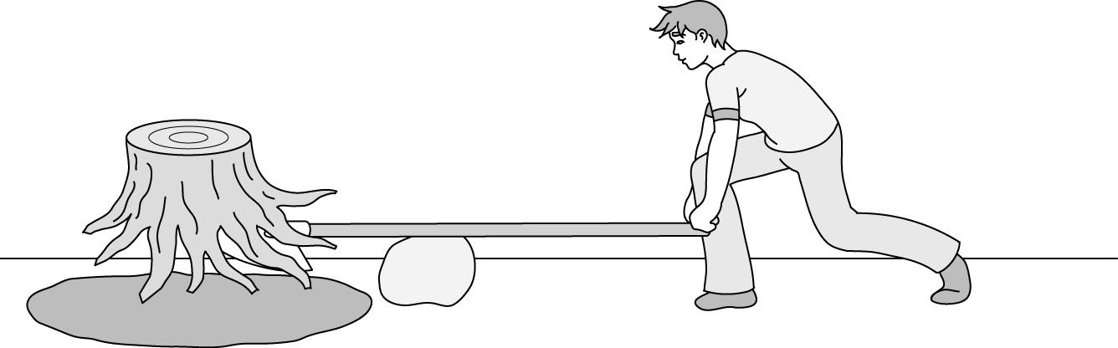

- C.

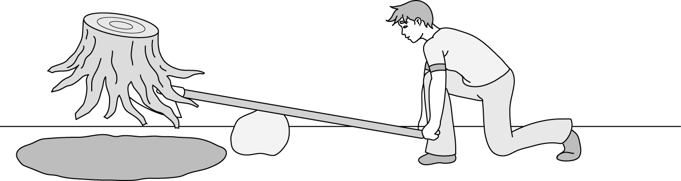

- D.

Tree Stump
3 Which lever system would require the least input force from Brian?
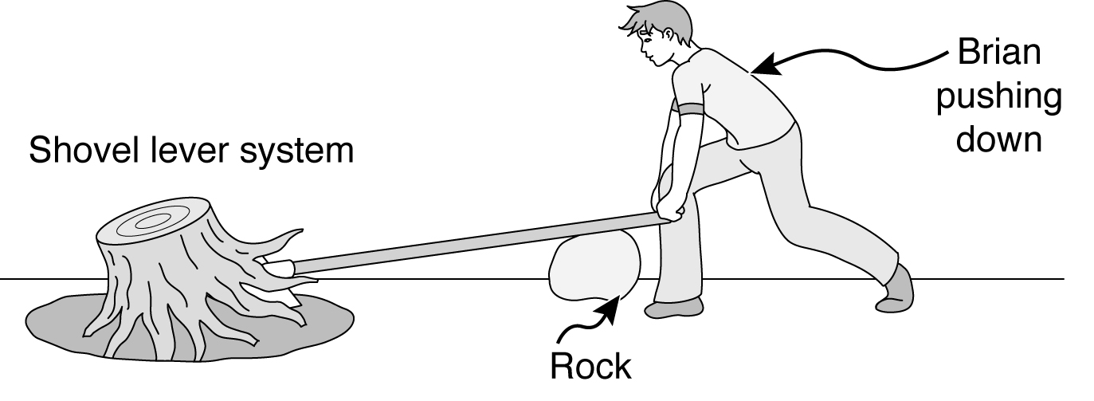

- A.

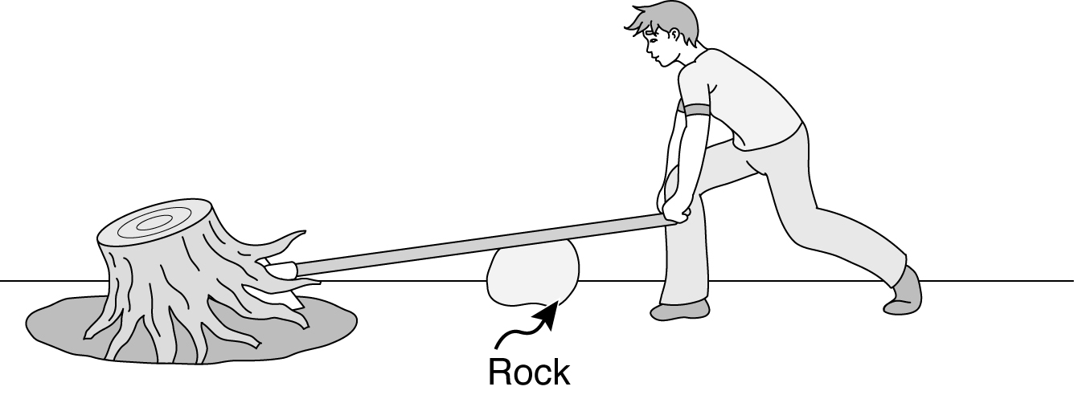

- B.

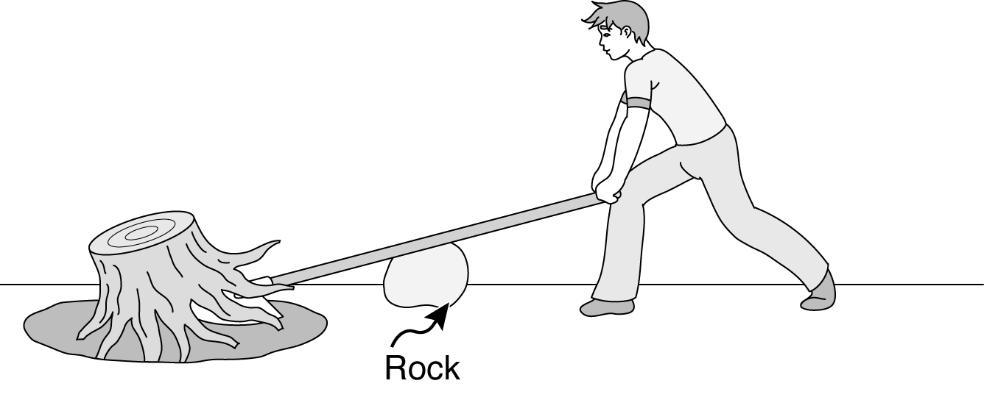

- C.

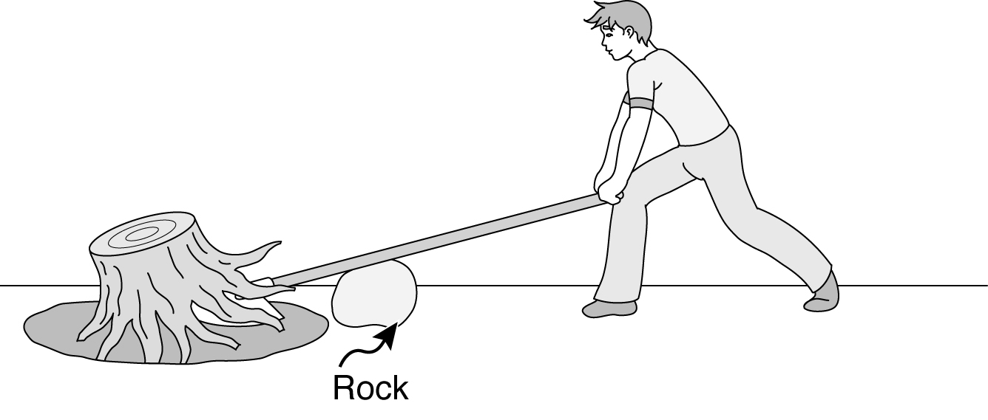

- D.

Tree Stump
4 Brian could have used a shorter, 3-foot-long shovel to lift the stump instead of the longer,
5-foot-long shovel. Describe how using a shorter shovel would change the solution to the problem of lifting the stump
In your description, be sure to:
  - Describe how the shorter handle changes the amount of force needed to lift the stump.
  - Describe how the problem of lifting the stump could be solved using the shorter shovel and the rock.
You may use words, labeled pictures, and/or labeled diagrams on the diagram in the box.
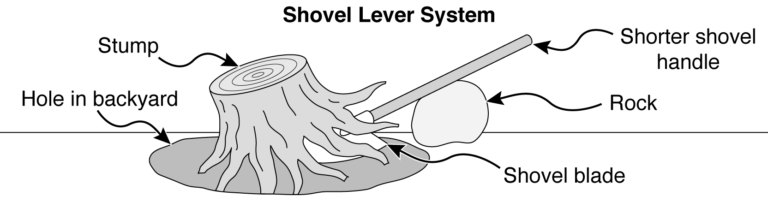
How the shorter handle changes the amount of force:
How the problem of lifting the shovel could be solved using the shorter shovel and
the rock:

Tree Stump
5 Brian’s neighbor had an even heavier loose stump to move out of a hole. Brian tried his Shovel Lever System, but the stump was too heavy. They had some other materials shown in the diagram below.

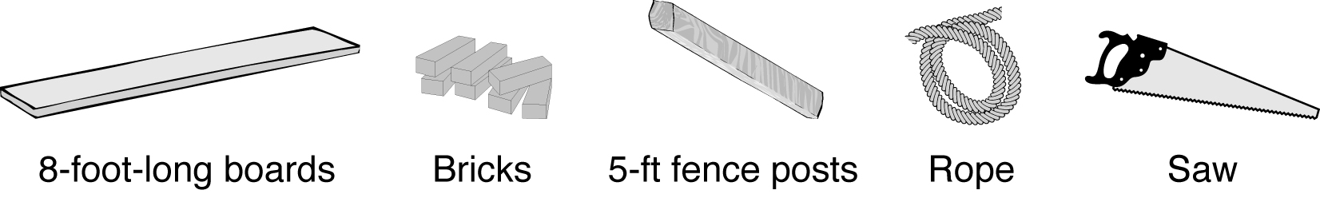

Using some or all of the materials shown, describe how you would design a way of lifting the heavier stump.
Be sure to describe the following stages of your design process:
- Gather Information: Describe the information needed and how to collect that information.
- Explore Ideas: Describe several ideas, including any useful scientific concepts.
- Plan Summary: Write a summary of the plan, including reasons for choosing this solution.
- Steps to Do the Plan: Write the steps, including all the materials used in the Plan Summary and in the Diagram of Solution.
- Diagram of Solution: Make a labeled diagram.
- Test Solution: Describe the process to measure or observe how well this solution may solve the problem.
Problem: Lift a heavy stump with some boards, bricks, and/or posts
Gather Information:
Explore Ideas:

Tree Stump
Plan Summary:
Steps to Do the Plan:
Diagram of Solution:
Test Solution:

Wild About Radishes
Directions: Use the following information to answer questions 1 through 7.

Amanda wanted to find out how acidic water affects plant growth. Amanda decided to do an investigation using radish plants and several water samples with different acidities as measured by pH.

Question: How does the acidity of water affect the height of radish plants?

Hypothesis (prediction): Radish plants given water with a pH of 7 will grow taller than radish plants given water with a pH lower than 7 because plants will not grow well with water
that is acidic.

Materials:
radish seeds
small plant pots filled with soil
water samples each with a different acidity: pH 4, pH 5, pH 6, and pH 7
graduated cylinders
labels
ruler
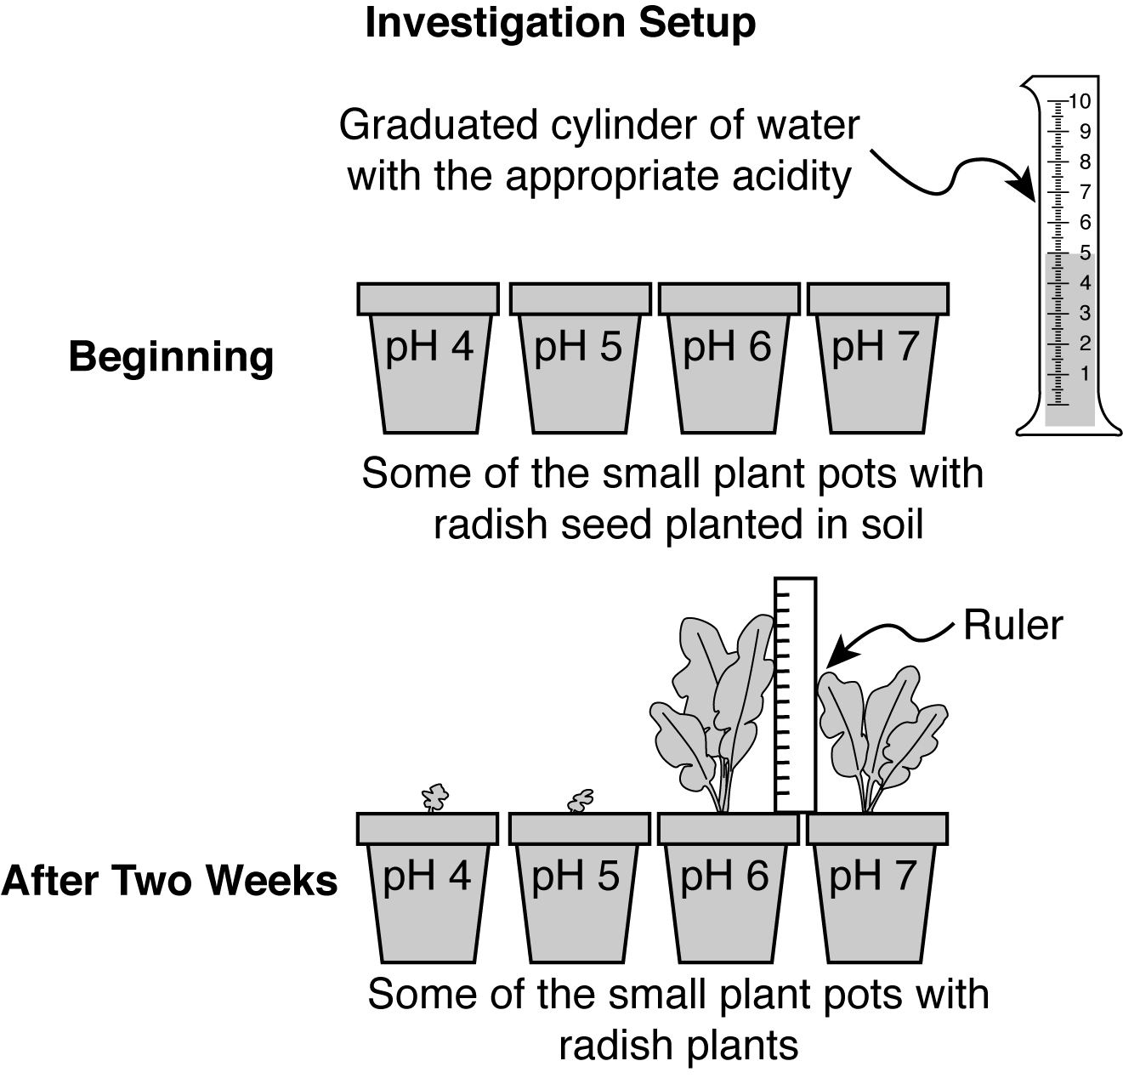

Wild About Radishes
Procedure:
- Label six pots pH 4, six pots pH 5, six pots pH 6, and six pots pH 7 as shown in the Investigation Setup diagram.
- Plant one radish seed in each pot.
- Every three days pour 5 milliliters of water with the labeled pH into each pot.
- Measure and record the height of the tallest leaf of each radish plant after watering.
- After two weeks, calculate and record the average plant height for each of the
four pH groups.

Data: The table below shows the calculated average plant heights for the six plants in each of
the groups.

Acidity of Water vs. Average Plant Height
Acidity of Water  (pH) | Average Plant Height  (centimeters)
4 | 0.5
5 | 0.5
6 | 12.5
7 | 9.0

Wild About Radishes
1 Which of the following variables was a controlled (kept the same) variable in
this investigation?
- A. Height of the radish plants
- B. Length of the radish roots
- C. Acidity of the water
- D. Amount of the water

2 How could Amanda make the investigation results more reliable?
- A. Change the type of seeds
- B. Repeat the entire investigation
- C. Change the amount of soil in each pot
- D. Increase the amount of water added each week

3 Which of the following systems in a human body performs the same function as the stem in a radish plant?
- A. Reproductive
- B. Circulatory
- C. Immune
- D. Nervous

4 What provides Amanda’s plants with the energy needed for growth?
- A. Air
- B. Soil
- C. Water
- D. Light

Wild About Radishes
5 Write a conclusion for the investigation.
In your conclusion, be sure to:
- Answer the investigative question.
- Include supporting data from the Acidity of Water vs. Average Plant Height table.
- Explain how these data support your conclusion.

Question: How does the acidity of water affect the height of radish plants?

Wild About Radishes
6 Describe two possible sources of error in Amanda’s investigation.
In your description, be sure to:
- Identify two possible sources of error in the investigation.
- Describe how each source of error could have affected the investigation results.

One possible source of error:
Another possible source of error:

Wild About Radishes
7 Plan a new investigation to answer the new question printed in the box.
In your plan, be sure to include:
- Hypothesis (prediction)
- Materials needed to do the investigation
- Procedure that includes:

- logical steps to do the investigation
- one controlled (kept the same) variable
- one manipulated (changed) variable
- one responding (dependent) variable
- how often measurements should be taken and recorded

Question: What is the effect of different amounts of pH 6 water on the height of plants?
Hypothesis (prediction):
Materials:
Procedure: You may use this space for a labeled diagram to support your procedure.

Wild About Radishes
Procedure (continued):

