Panama Canal
Facts
Here are a few facts about the Panama Canal:

- The Panama Canal is 85 feet above sea level
- The construction of Panama Canal started in 1904 and was finished in 1914
- Panama Canal is located 800 miles north of the equator
- The Canal is 107 miles long and is 10 miles wide radius.
- The French killed 16,000 people in there first attempt to build the Canal
- The first boat passed through the Canal was in 1914.
- The average amount of ships to go through the Canal a day is 36.
- Theodore Roosevelt chose to build the Canal wile touring in Panama.

Panama Canal
123 Main Street, Suite 100
Any City, ST 12345-6789
Phone (123) 555-0000
Fax (123) 555-0000

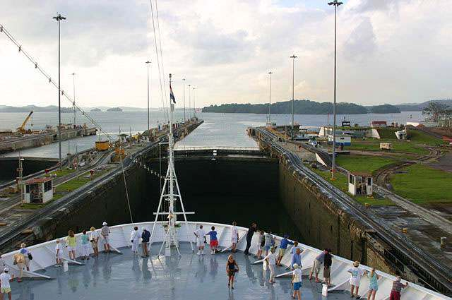

Panama
Canal

From the
Atlantic to the
Pacific

Who built the Canal?
The French were the first people to attempt to build the Panama Canal. They had failed to do this because of Yellow Fever and Malaria. The United States we’re the second to build the Canal, and after 10 years, in 1914 the Canal was finished.

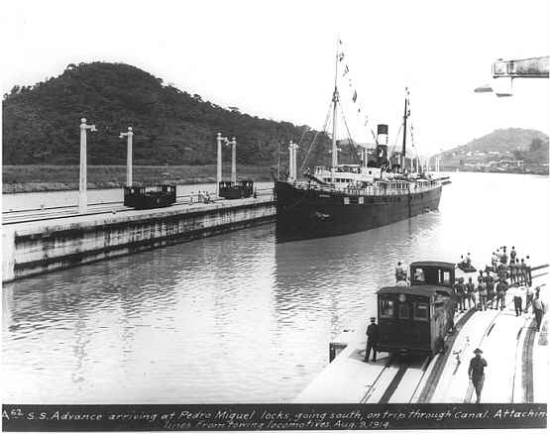
Here is one of the first boats to go through the canal around 1914. The very first boat to go through the Canal on August 15,1914 was called the Ancon.

Why use the Canal?
?
History of The Panama Canal.

Why would you want to use the Panama Canal and have to pay an average of 34,000 dollars for a toll , charge? Well many reasons, and the biggest reason being that using the Canal cuts down your time by far! Without the Canal you would have to travel around the continent. By using the Canal you can save 8,000 miles! There are down sides to using the Canal. For one you have to pay an average of 34,000 dollars depending on the weight of your boat. Another disadvantage is you can always run into traffic!
In the 1500’s the land was owned by Spain but they were all killed by disease, slavery, and warfare. Later when Panama became part of the South American country of Colombia, they refused to let the United States build a canal the Panamanian’s decided to became there own country .But In 1904 the United States took over Panama and soon after the Panama Canal was built and finished in 1914. After the first attempt by the French who failed because the workers were dying and they didn’t have enough money. The first president to suggest to construct the Canal in 1904 was Theodore Roosevelt while he was touring Panama. In 1978 President Jimmy Carter signed a treaty to give the Canal back to Panama and Panama finally became there own country. This decision was made after many riots during 1964 showing frustration over American control. The riots killed 4 Americans and 24 Panamanians.

