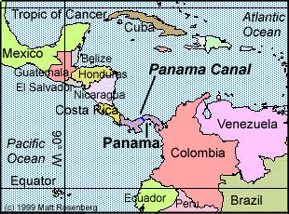

Panama Canal facts
Interesting facts about the Panama Canal :

1.Did you know that 41 feet is the highest sea level of the Canal.

The Panama Canal was built so ships could go in and out.

It tock two try’s to finish build the Panama Canal.

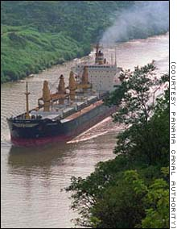

Panama

Canal

4689 Hotgregy St.
call: #1-666-9876
fax: # 1-666-5479

Call: 1-666-9876
Environment:

Panama is the only City in the world in which a protected, tropical rainforest can be found within city limits. The country
Has many and varied outdoor attractions from the mountain region of Chiriqui` to the beaches on the Caribbean coast.

Geography:
The republic of Panama with an area of approximately 29,700 sq. Miles (76,900 sq. km) , located between Costa Rica and Colombia, forms the narrow west and lowest portion of the Isthmus that links North and South America shaped like an elongated letter “S” which extends west to east some 420 miles (676 km.), the country has width that varies between 31 and 115 miles 50 and 115 miles (50 and 185 km,) and has a coastline of 490 miles (788 km.) on the Atlantic Ocean and 870 miles (1,400 kin.) on the Pacific Ocean. The Canal, which joins the Atlantic and the Pacific Ocean is about 50 miles (80 km.) long. Because of the lateral nature of its extension and its extension and its curved contour, directions are often surprising. A transit of the Canal from the Pacific to the Atlantic involves traveling not to the East but to the North-West; in Panama City the sun is seen to rise out of the Pacific.

Water,Canal,&woods

The Chagres National Park covers 320,000 acres (129,000 ha.) of rainforest that provides 40.0% of the fresh water that goes into the inter-oceanic waterway. The Soberania National Park of 55,000 (22,104 ha) is a perfect example of tropical forest boasting an amazing biodiversity. Due to the vital importance of water for the Canal’s operation and the direct inter-relation between the rainy tropical forest and the pluvial precipitation wooded areas that were been converted surround the Canal into satate managed national parks and ensuring the water supply, these protected areas are also used for ecotourism as well as for scientific research.

