Famous Landmarks

Panama Canal Museum


Also…
Gatun Lake.

Panama Railroad.

Spanish ruins @ Portolebo.

Darien National Park.

San Blas Islands.
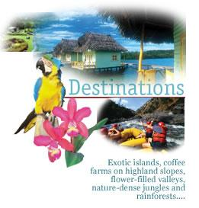

Contacts
Embassy of the
Republic of Panama
2682 McGill Terrace, N.W.
Washington, DC 20008
(202) 483-1407

Panama Canal Museum
http//www.canalmuseum.com/

Panama Canal

Ocean to Ocean

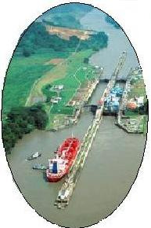

““
An Informational guide to

“The Big Ditch”
and surrounding attractions.

The construction of the Panama Canal was taken over by the United States in 1904 after the French attempt turned into a major disaster. This American project is still considered one of the most extraordinary feats of engineering ever accomplished. The project was finished in 1914 with the cost amounting to approximately $387 million. Had it not been for Colonel William Crawford Gorgas thousands of people would have died because of Yellow Fever carried by mosquitoes, but Colonel Gorgas rid all of the mosquitoes by covering all still water and destroying all other mosquito breeding grounds.

The Gatun locks while opening.

History

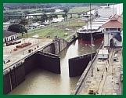
Construction
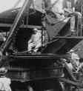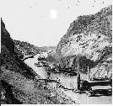
The country of Panama connects Central South America. The Panama Canal is one of the most popular tourist destinations in the new world. Around the Canal there are various museums and visitor centers. Panama offers a tropical maritime climate, fabulous beaches and 14 national parks. Cruise Ships from North America often stop near the popular San Blas Islands or travel through the Canal. A number of major improvements have been made to the Canal. The Madden Dam was built on the upper Chagres and a state-of-the-art bridge, called the Bridge of the Americas, was built to span the Pacific entrance to the Canal.

The Bridge of the Americas.
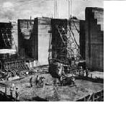
One of the major lock systems is the Gatun lock, located at Gatun lake. This lake is the largest man-made lake in the world and was made by damming the Chagres River and diverting the water thru a channel in to the crater they had dug.
The Panama Canal connects the Atlantic Ocean on the east and the lower Pacific Ocean to the west. This major waterway, with its six sets of locks, saves 8,000 water miles!!.

The Canal Today

