HELP AND FACTS

- Hi, we are the Panama Canal people serving you with your traveling needs.

- We are the people that you can trust if you are traveling to the Pacific Ocean and you are on the Atlantic Ocean. Please visit us and we will help you!

3. If we didn’t build the canal everybody would have to travel way longer. Building the canal saved 8,000 miles of traveling! Now aren’t you happy?

DIFFERENCES AND SIMILARITIES ABOUT THE PANAMA CANAL AND THE BALLARD LOCKS
THEY ARE ALIKE BECAUSE THEY BOTH HAVE BOATS TRAVELING THROUGH IT. THEY ARE DIFFERENT BECAUSE ONE IS IN PANAMA AND ONE IS IN WASHINGTON.

CONTACTING INFO IS UNDER THIS PICTURE

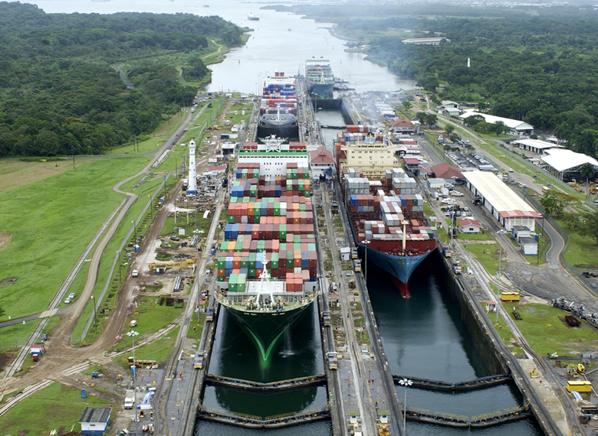

Panama Canal People
123 Main Street, Suite 100
Any City, ST 12345-6789
Phone (361) 666-5987
Fax (361) 666-5986
www.panamacanalpeople.com

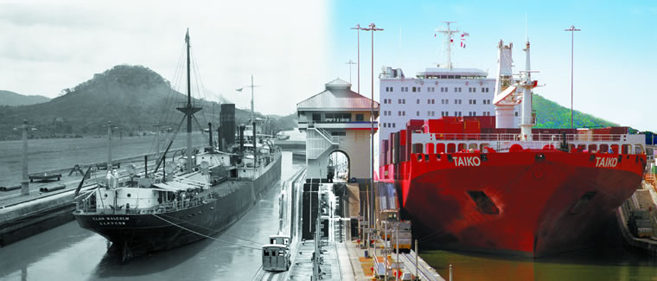

The People That You can Trust!

The Panama Canal People

Traveling needs through the Pacific to the Atlantic or through the Atlantic to the Pacific
information about panama canal
- The Panama Canal is a passageway through Panama so boats can go through or large ships or cargo ships to go to the Pacific or to go to the Atlantic.
2. The Panama Canal was made for ships transporting goods faster so they don’t have to go around South America. Also just for cruises so the cruise aren’t so long and so they can get home faster.

3. The first to attempt to build the Panama Canal were the French. They did not succeed, because they quit after 16,000 people died mostly from diseases and because they ran out of money to buy supplies

4. Then the U.S tried and they succeeded, because they had the money to buy supplies and recruits of workers.

5. The U.S started to build the Panama Canal on 1904 and they finished on 1914.

EVEN MORE INFO ABOUT THE PANAMA CANAL
The average amount of ships going through the Panama Canal is between 18 and 16.

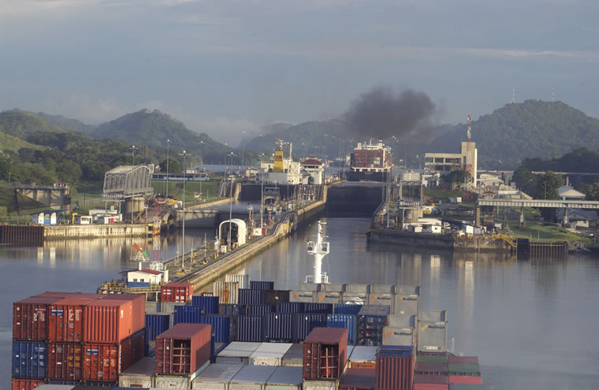

1. There were 2 kinds of diseases that slowed down the workers of the building of the Panama Canal and they were yellow fever and malaria.
2. The Panama Canal was owned by America for a while until Panama took over on December 31, 1999.

3. Hundreds of people wanted the canal built in Panama so they can have a shortcut through Panama.

OTHER TIPS
4. 2 out of 3 people died from diseases trying to build the Panama Canal. Jungle fever was 1 of the many diseases that killed many people.

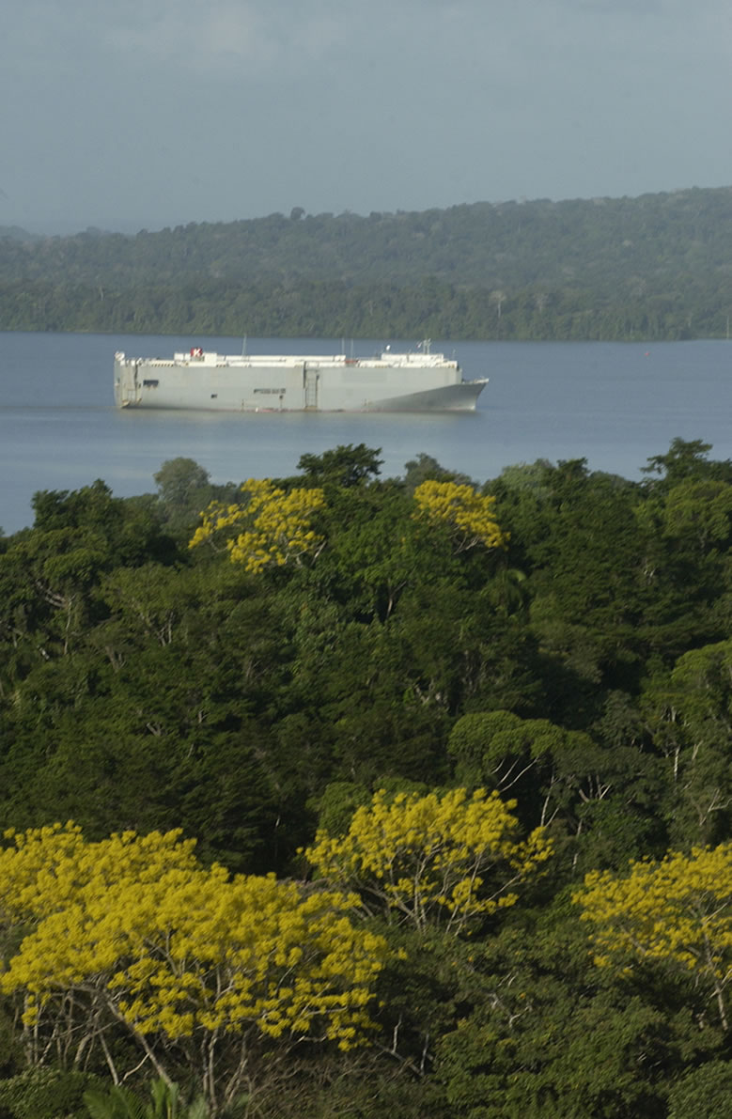

CALL (361) 666-5987

