The History of the Panama Canal.
- The French started building the canal because it would save ships 8000 miles.

- When the French failed because of yellow fever and malaria the Americans finished it.

- The Panama Canal was built to make a shortcut through south- America.
Who built the Panama Canal?
The French started the canal but failed because of yellow fever and malaria. Then, we, the Americans came in and finished it. Then on December 31 1999 Jimmy Carter signed the treaty that gave the Panama Canal to Panama.

Also don’t forget to visit our web site
or call for more information about
Panama Canal.

Panama canal co.
123 Main Street, Suite 100
Any City, ST 12345-6789
Phone (123) 555-0000
Fax (123) 555-0000
www.panamacanalco.com

Panama
Canal co.

Call 555-0000 for more information.

I hope you will enjoy reading this brochure!

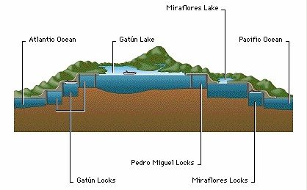
How the locks work
Well if your going though from the pacific then they will drain the water on the other side then they open the locks and so you can go through and then they will shut the locks and fill them back up then they will open the other side and then you can go through. They will repeat the same process on the other locks and that’s how the locks work.

Interesting facts you don’t know about the canal.

- The Panama Canal is more than 80 km long!
- The highest part of the canal above sea level is 85ft.
3.Prices for a trip through the canal depend on the weight and what kind of cargo is on the ship.
4.When French were building the canal, they had to quit because 16,000 people died of diseases such as malaria and yellow fewer.
5.Americans were second to try to build the canal, and they had succeeded, because they had better machinery then the French at the time.

Don’t confuse the Panama Canal and the Ballard locks.

So what’s the difference between the Panama Canal and the Ballard locks?
- Well for one thing the Panama canal is much bigger than the Ballard locks.
- The Panama canal also has more locks than the Ballard
locks.

Why should you use the Panama Canal?
Well, if you are traveling
With your family to a certain country in South America, but you’ll have to go all around the two continents to get there and you will certainly be a little sad about it, but there is something that can help you with your problem, and it’s a Panama Canal, as you maybe already understand this canal is in Panama. No matter where across the continent you have to go, Panama Canal will make your way much shorter!

