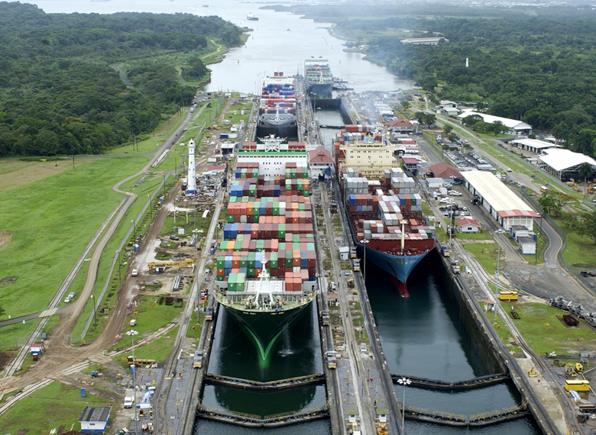
PANAMA CANAL
The Panama Canal was built to help family’s to expand their trades, help the United States defend themselves, and warships could move to wars quicker.
The Canal is 107 miles long. On the canal there’s small electric locomotives called mules.
The United States built the Panama Canal second. Yes they succeeded, other than the French who didn’t. They picked Panama because they didn’t want to go all the way around the country so they picked the smallest land part of Panama to ship goods and so you wouldn’t have to spend more money on trains and planes.

Gabby/Kaitlyn Inc.
600 Main Street Suite 2
Port Hadlock, WA 98399
Phone (360) 437-9633
(360) 385-0236
Fax (360) 385-0237
www.Gabby/Kaitlyninc.com

Panama Canal

Gabby n’ Kaitlyn’s inc.

Facts about Panama Canal

- The highest part of the Canal is 85 feet above sea level.
- The two worst diseases that killed workers were yellow fever and jungle fever.
- President Theodore Roosevelt was most responsible for the Canal.
- August 15, 1915 was the year the first boat made an official passage through the Canal.
- The Canal is 107 miles long.
- Panama obtained control over the Canal in 1977.
- It took the United States 10 years to build the Panama Canal.
- A boat coming from the Pacific Ocean to the Atlantic Ocean going through the Canal goes north.
- Columbia owned the Panama area before the United States helped Panama for its own country.
- The average number of boats that go through the Canal each day is 36.
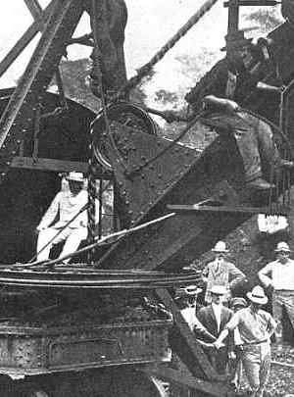
US President Theodore Roosevelt visiting the Panama worksite 1906.

Theodore Roosevelt signed the treaty to give the canal back to Panama. Panama got ownership of the Canal Zone in 1978. The average amount of money paid by each ship going through the Canal is $34,000. The reason the French did not succeed is mostly because of money, and diseases. The narrow strip of land they used in Panama is called an isthmus. It took 10 years to build the canal for the United States and did you know that Columbia was the country that owned the Panama area before the United States helped Panama form its own country.
In this picture (-below-) you will see the Culebra cut made by the U.S in 1904. It shows how deep they dug to build the Panama Canal. They used spoil cars to help them make the canal, over 115 locomotives hauled more than 2,300 spoil cars of every size. Most of the cars were made out of wood. About 160 loaded trains went out of the cut daily.
Culebra Cut 1904
The US operation starts.
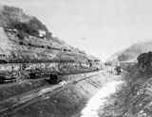

CALL 437-9633 or 385-0236

