Going To The Panama Canal
Going On This Cruse. You Will
See The Following.
- You will see the Panama Canal locks. It will take about 50 miles to get through the whole canal.

- The Panama Canal charges you a toll but if you’re on the cruse you don’t have to pay.

- If you go on the cruse you will have lots of fun. You will have great rooms, good food, and a great view

Tolls for The Panama Canal
The Canal Charges about $950 for a toll. The ship is parity big. It takes about 8 hours.
It really depends on what kind of boat you have or are going on.

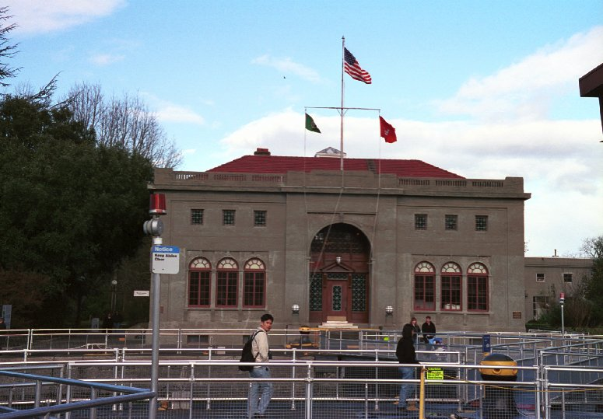

The Cruse Company
123 Main Street, Suite 100
Any City, ST 12345-6789
Phone (153) 555-3698
Fax (153) 555-8754
www.thecrusecompany.com

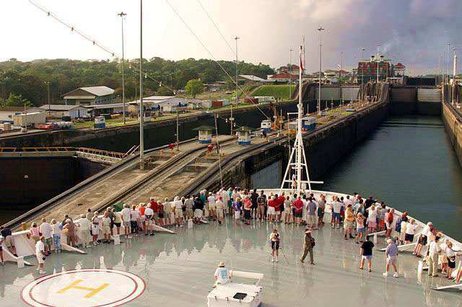

The Panama Canal
The Best Cruse You Will Ever Go On!!

The Cruse Company
The Cruse Company

We provide a service for you to go on The Panama Canal Cruse and see all of the canal locks.

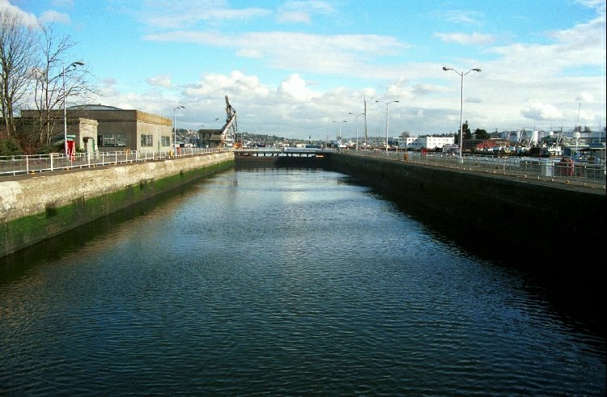

The Panama Canal is 800 miles north of the equator. It separates two oceans. Theodore Roosevelt had the most responsibility of the canal. Lots of people died of the two deadly diseases called Yellow Fever and Malaria. It took the workers 10 years to finish the Panama Canal. The bridge was built because people had to go across the water to achieve daily tasks. About 30 ships a day would go across the Panama Canal.

You can go swimming, you can watch a live band, and you can even do karaoke. You can take great pictures of the water and the Canal.
The Canal is a very beautiful place. You can hang out with friends and family. The cost is $950. But we know you will love it there because it’s worth it. You will love it!!!

Our team learned a lot about the great Panama Canal!! It was very interesting. We had a great adventure!! The most exciting part was watching the movie about the Panama Canal. The difference about Panama Canal
and the Ballard Locks are the Panama Canal is in Panama and the Ballard Locks are in Washington, the two of them both have different names, and the Panama Canal has had a lot more tragedies then the Ballard Locks. The things Panama Canal and the Ballard Locks have I common are they are both bridges and they both have boats and ships that go across them.

This is a picture about a boat going through the Panama Canal! Boats like this go by here every day. Big boats like cruise ships to little boats like tugboats. About 35 ships a day pass through the canal.

CALL (154) 555-3698
