Chimacum Middle School
Mr. Al González, Science

Standards-Based Grading – No More A’s or F’s!
I’m going to change the way I grade my students for the 3rd trimester. I’m going to stop giving grades!! What, you might ask. Well, I’ve been doing some reading and I’ve been discussing this issue with teachers from around the world and I’m convinced that abolishing grades will help my students!

My Research about Learning
I wrote an article on my blog called, Do Grades Help or Hinder Learning? (http://www.educatoral.com/wordpress/?p=246) As 2nd trimester came to an end and I prepared final grades I was left wondering if grades and marks like grades help or hinder learning. I began to wonder about grading after reading an article by Alfie Kohn, From Degrading to De-Grading (http://www.alfiekohn.org/teaching/fdtd-g.htm). What impressed me about the article was that it showed me the solution to a problem I’ve been seeing year after year, namely F’s and D’s. I have not been happy with the amount of low grades students get in my classes. Every year I try new things to get all my students to be successful but I still have students failing and feeling like failures. In learning, failing is an important step because we learn from our mistakes. But making mistakes doesn’t make us failures! And the part that has been even more difficult for me to swallow is that I know the work students are doing in my classes is good! I can see their learning every day and yet if an assignment is missed, lost, or not completed that child gets a low mark and a low average labeling him or her a failure. That is so wrong! Grades are merely a way to rank students to see who are at the top. Why?

I’m currently reading Punished by Rewards by Alfie Kohn (http://www.alfiekohn.org/books/pbr.htm). My goal is to create an atmosphere where my students will learn and be excited about learning without worrying about grades or failure. I don’t want to discourage children with anything considered a low mark because we get discouraged and turned off to learning when we get low grades. Everyone knows that getting a failing grade is undesirable but here’s the part many of us don’t know, students who work for A’s end up not learning as much as students who are not graded! Think about it, students will do what it takes to get an A even if they could have learned more about a topic. Once a student learns that he or she got an A, learning stops because they feel that they are done. I just want my students to learn until they understand or to learn for the joy of learning! What I believe is important for students, parents and teachers to talk about in conferences is how the child is learning, what the child is learning and how the child treats others. I’d rather not rate my students with letter or number grades. What it boils down to is that students should experience success and failure not as rewards and punishments but as information.

I’ve put together a short survey, just six questions, to see what you and your family believes about grades and learning. Here’s a link to take the survey online: http://www.surveymonkey.com/s/GKDDFSZ

For the Science standards students will learn I will use this rubric:
Shows Understanding of this Standard
Shows an Incomplete Understanding of this Standard
Beginning to Understand this Standard
Needs to Show More Evidence of Learning this Standard
NO FAILURES!
The description or comments I make are more important than numbers. Research shows that when there is a number or mark students pay little to no attention to the written description. My goal is to have NO marks or numbers attached to feedback my students get in class. Most of the feedback I give is when I’m walking around helping students in class and THAT’S where the learning takes place! Also of importance is when students self-evaluate and I will have students self-evaluate often. That will help students prepare for their student-led conferences. So parents and students won’t see numbers or letter grades until they check Skyward at the midterm or end of term (and only then because I have to). Here is a sample progress report:

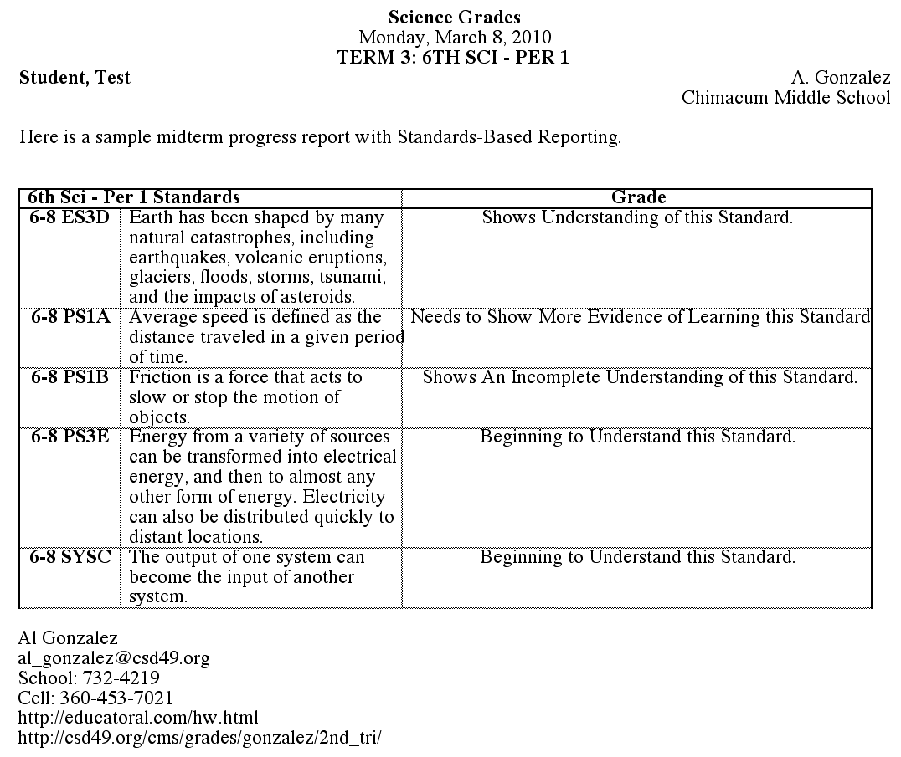
I post news, updates and articles on my website, http://educatoral.com/wordpress/, so check it often to keep up with Science. My website is the best way to find out what your child is doing so also bookmark http://educatoral.com/hw.html where I write down what we do everyday in class. I see about 148 students everyday so I will only post general information about all my classes on the website as opposed to individual information about each student. If you need to contact me you can email me at al_gonzalez@csd49.org or text or leave a voicemail at 360-453-7021. I will also have my 3rd trimester progress reports online, to save paper, at http://csd49.org/cms/grades/gonzalez/3rd_tri/.

