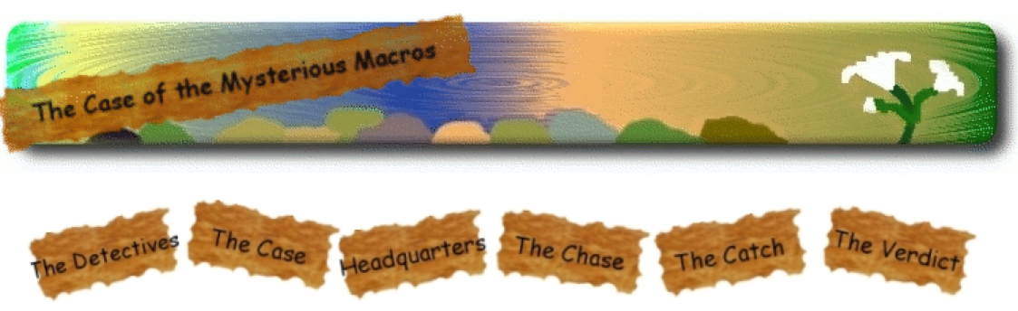

For each paragraph in each page you need to write the main idea. That’s just one sentence written for each paragraph you read. This was assigned so that you can all practice reading instead of skimming. Science needs to be read slowly and carefully.

Number of sentences needed for each section:

The Case – 12
Should have a total of about 125 sentences (or 101 to 149 sentences)!

Headquarters – 6
The Chase – 15
The Catch – 8
The Verdict – 9
The Mysterious Macros – 3
What is a Watershed? – 11
Water Temp & pH – 10
Water Pollution – 17
Aquatic Ecosystems – 11
Life Cycle of Aquatic Insects – 6
Get Involved – 17

