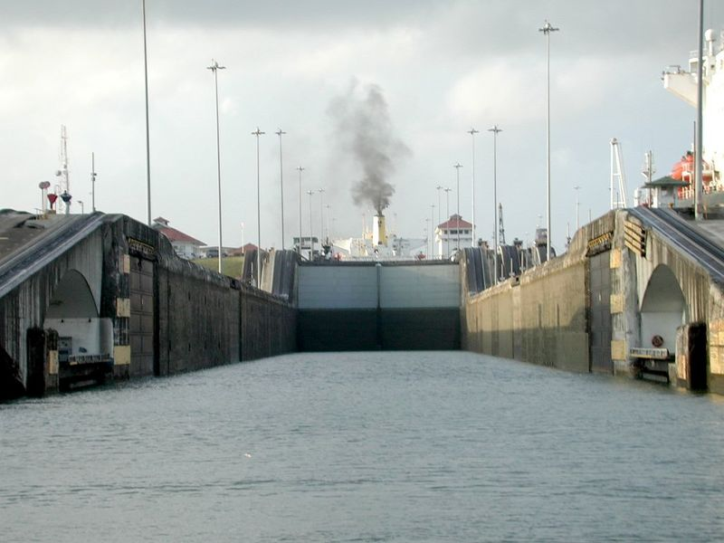

TEDDY ROOSEVELT WAS THE FIRST PRESIDENT TO COMPLETE THE PANAMA CANAL!!!

These are some quick facts!!

- The United States was the first country to complete the Panama Canal.
- The England peoples did NOT finish the Panama Canal.
- Theodore Roosevelt became president of the United States and he thought that if we built the canal through Panama that the United States would be more powerful.
- The French who built the Suez Canal attempted to build a sea level canal though Panama.
- The French FAILED to complete the canal though Panama.
- The French killed 16,000 people that helped with the canal.

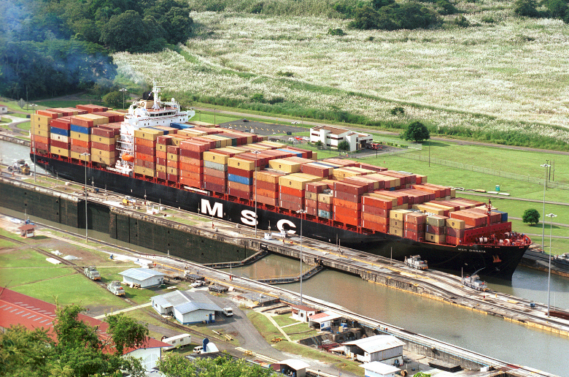

1234 cool-rider lane
CITY: PANAMA CITY
PHONE: (360)-321-0204
FAX (360)-123-4857
VISIT OUR WEBSITE AT
WWW.PANAMA INC.COM

PANAMA CANAL

THIS IS WHAT YOU NEED TO KNOW TO TRAVEL THROUGHT THE PANAMA CANAL:
BIG SHIP (LIKE ONE IN THE PICTURE)
100,000 DOLLARS
SMALL SHIPS: 1,000 DOLLARS
AND IF YOU HAVE ANYMORE QUESTIONS PLEASE CALL:
(360)-321-0204
OR FAX US AT:
(360)-123-4857
THANK YOU!!

Now I am going to show you some pictures of the Ballard locks.
The Ballard locks is what they have in Panama this is what the boats go through.

.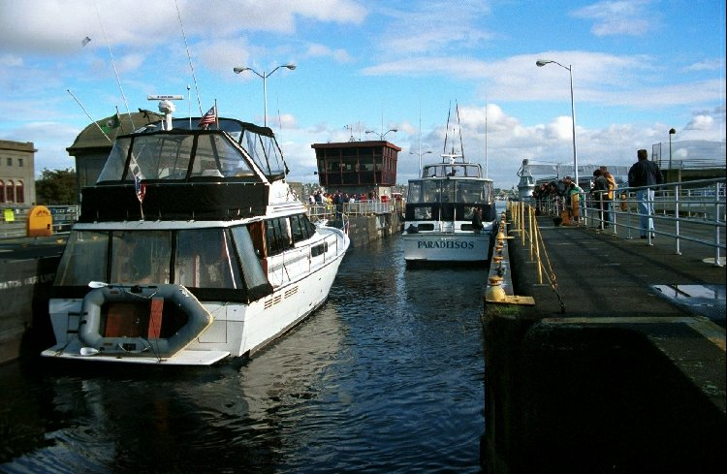

This is a picture of a boat going through the Ballard locks.

This is a picture of a piece of the locks when NO boat is in it.

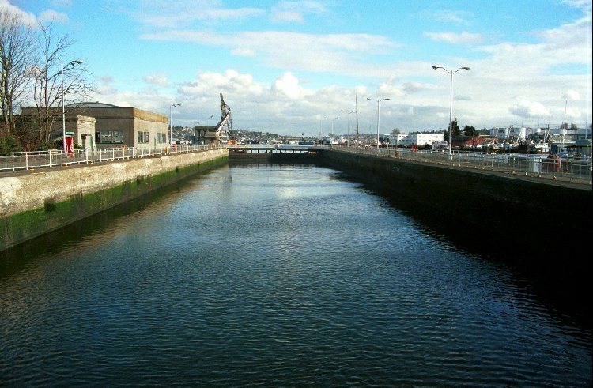

Now I am going to show you some more pictures about the Ballard locks.

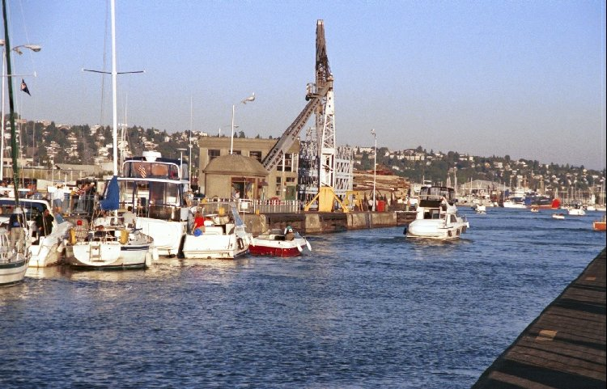

This is a boat that has just gotten out of the Ballard Locks.
Is the Ballard locks just for boats?
NO!
The Ballard locks are used for different things they are also used for salmon. When the salmon come up to spawn this is one way they can come.
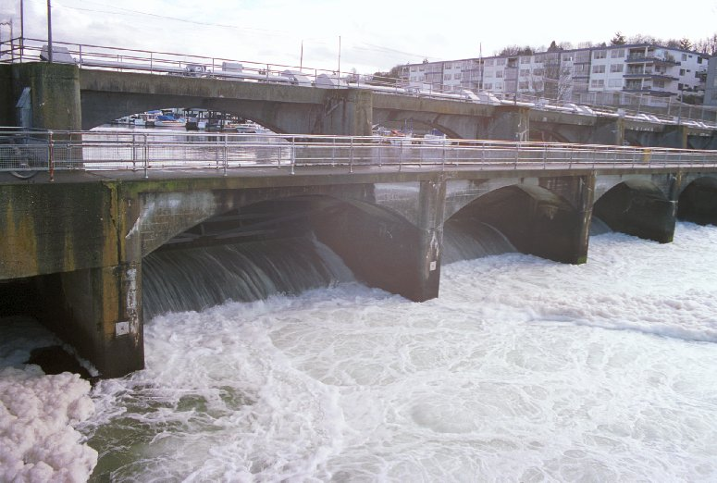

This is a picture of the way the water runs through from fresh to salt.

Now I want to say how the Ballard locks work:

The way the locks work is the pipes.
The water runs through the pipes.
The people that work at the locks are able to put water in and take water out by them.
When the gate closes the water rises so it can go into the next piece.
Then when it rises then it goes into the next piece, when it is in the next section then the water will sink so it can go into the next one.
Then when it goes through the last one then it has made it across, so it doesn’t have to go through anymore locks!!

PANAMA INC.

WISH YOU WERE HERE

WELL YOUR IN LUC
IF U CALL NOW YOU WILL GET A FREE NIGHT STAY AT
PANAMA INN!!!

SERVICE YOUR COMPANY PROVIDES

